OSA-CT, MAY 2012, STREET REPORT
Bridgeport – 83 surgical abortions, 5 changed minds
New Haven -25 surgical abortions, 1 changed mind
TOTALS since 1990: 2212 babies saved, 402 salvations
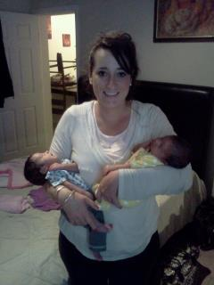
This is Brenda with the “miracle” twins born on April 25th, 2012. Baby Jaden weighed 4.3 pounds and baby Jada 3.10 pounds at birth. They only had to stay in the hospital two weeks even though they were born two months early. God blessed these precious little ones with good health. PTL! Please pray for this family of 8 children. When the twins get bigger the parents want to come to church. Blessed is the man whose quiver is full of children! (Psalm 127)
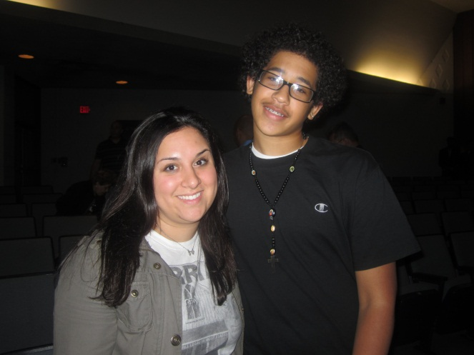
This is Kelly and Deonte (14). He is one of the babies saved at Summit
who attended the bible club concert at the high school were Kelly is a teacher.
Many of high school students attended the spirit lead concert and many of the
students rededicated their lives to Christ including Deonte! Please continue to
pray for him.

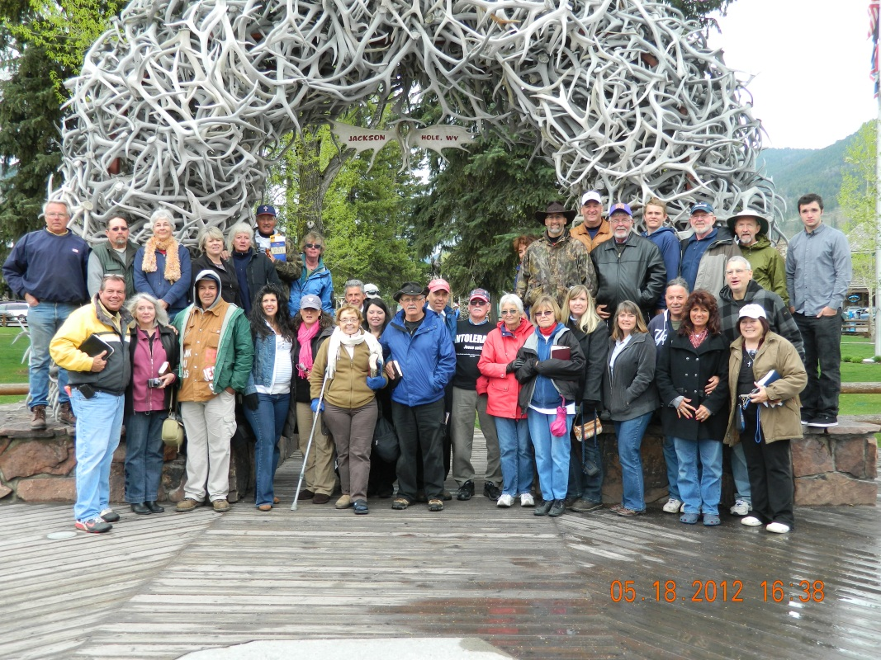
Carmen, Brenda, Danny and Marilyn met up with other OSA people from around the country to bring the truth of the Gospel to Jackson Hole, Wyoming May 15-19th. We brought the truth through the Gospel and are hoping that Wyoming will become one of the first abortion free states. We were able to publicly read the whole word of God the days we were out there on the streets. We also went to the high school every morning with signs and literature. We had many witnessing opportunities and more and more people are learning what God’s word says about killing babies. There are five states (Wyoming, Arkansas, Mississippi, South Dakota, North Dakota) we are addressing that have only one free standing surgical business. Please keep this in your prayers. www.statesofrefuge.org

Here is Shaylah, AJ’s mom who changed her mind at PPNH a couple of years ago. She will be moving with her son to Pennsylvania to live at Wilson College. She got a full scholarship; she is valedictorian of her senior class at Hillhouse High School. We are very proud of Shaylah, her love for the Lord has helped her to overcome difficult situations in her life.
“Be strong and take heart, all you who hope in the Lord.” Psalm 31:24
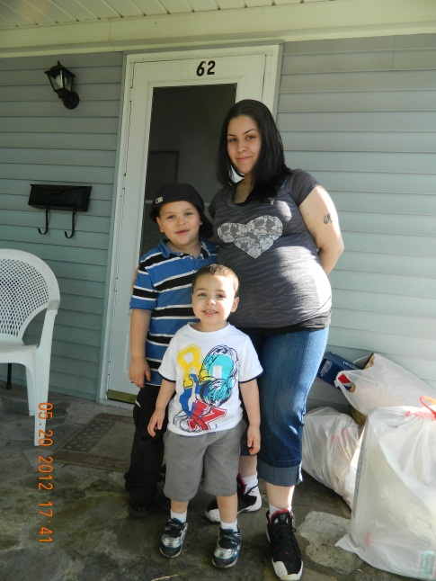
This is Frances, we met her last month when she changed her mind and decided to keep her baby. She is a lovely young lady and has three sons (5yr,2yr, 4months) and a baby in her womb. She recently moved into a new apartment and needed a bed and dressers that we were able to supply. She is very appreciative for the diapers and clothes and feels better knowing we will be there for her. She wants to come to church and a couple of people have volunteered to give her a ride. Please pray for her salvation and for her work schedule to open up for the right days and times. She told me she has been praying to God and I encouraged her to read the Bible we gave her.

“A generous person will be blessed because he shares his food with the poor.” Proverbs 22:9

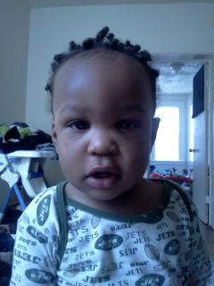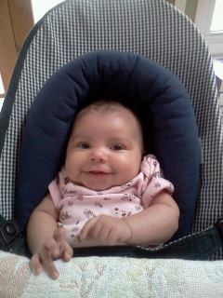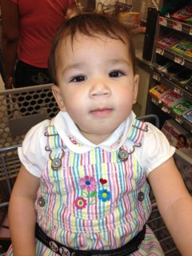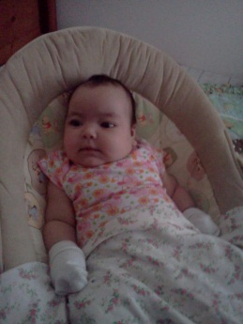
Every life is precious and valuable to God and to us!

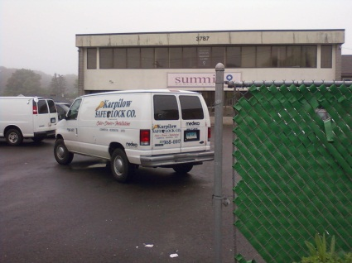
Karpilow Safe Lock Co. is another business that services the death mill. Please do not use them and let others know not to either.
“It takes a village to kill a child!” www.bloodworker.com Take pictures and send them to 2f@tonymassey.com .
This is the section for Connecticut: http://www.coldbloodworker.com/connecticut/

NEEDS FOR THE MINISTRY: Stop & Shop food cards and diapers, all sizes 2-6 and wipes.
We need your help, we cannot do this alone. THANK YOU!
OSA-CT, 632 Merwin Ave. Milford CT 06460

