September, 2012

Exposing Abortionists in Charlotte

Operation Save America just completed a powerful National Event this past July, storming the gates of hell in Charlotte, North Carolina, heralding the true King of the Queen city – Jesus! We brought the Gospel of the Kingdom to the streets, death camps, abortionist's residences, offices, apostate churches, and exposed Stericycle's complicity in the American holocaust. The theology of the church house became biography in the streets of Charlotte. Ten babies were saved that wonderful week and many folks gave their hearts to Christ.
The Democratic National Convention (DNC) will be arriving in Charlotte the first week in September to coronate its false messiah and attempt to usher us into another four years of the culture of death. Everything this Party stands for brings death – abortion, euthanasia, homosexuality, the end of the institution of marriage, debt, any religion but Christianity, ad nauseam. The DNC is indeed the culture of death. God put it this way, “…All who hate me love death.” Proverbs 8:36. Bottom line; the DNC hates the God of the Bible – Jesus!
Anytime the Church of Jesus Christ makes a meaningful advance of God's Kingdom against evil, the enemy retaliates. It is the nature of the battle we Christians fight. Perhaps, this is one reason why the church in America turns a blind eye and a deaf ear to the injustices of our age. She would rather live with injustice and evil and maintain peace with the world, the flesh, and the devil, than to confront evil and defeat it.
Thank God for you who are willing to pay the price to see evil exposed and righteousness upheld. Mere days after our National Event, the authorities contacted Flip and summoned him to a bond revocation hearing on Friday, August 10, 2012. The city was seeking to stop this aberrant Christian behavior immediately. As most of you know, Flip was out on bond while awaiting an Appeals Court decision on a totally ludicrous “stalking” charge. Brother Flip was found guilty of “stalking” for passing out Gospel literature at an abortionist’s practice, abortion mill, and neighborhood. Though Flip honored all the conditions of the court order, the Feminist Majority ladies felt it was time to get him off the streets. They tried, and they failed. Praise the Lord!
Charlotte Attempts to Silence Christians before DNC!

Charlotte, North Carolina: Operation Save America (OSA) has been lifting up the banner of Christ at abortion mills in the city of Charlotte for years. On July 21-28, 2012, OSA brought pro-life leaders from across the country to Charlotte to shine the light and draw battle lines between the culture of death and the culture of life by confronting the Democratic National Convention (DNC) with the claims of Christ.

“Have nothing to do with the fruitless deeds of darkness, but rather expose them.” Ephesians 5:11.
A video taken during a visit to the home of abortionist Ron Virmani, where he called the children he murdered, “those ugly black babies,” went viral on the web. It exposed the hatred and racism that exists at the root of the hideous lie of abortion. This language is not new to those who plead for lives of children at the abortion mills.

Watch the video at: http://www.youtube.com/watch?feature=player_embedded&v=RH0QT_p481o
The DNC does not want the black community to see the racist roots of its “death agenda.” Nor does it want it known that abortionist Virmani is a staunch Democrat. Abortion is the summum bonum of the (DNC)
Mere days after the OSA event, Rev Flip Benham, director of Operation Save America, was summoned to appear before the Superior Court of Mecklenburg County for the revoking of his bond. Benham was on bond while his case was being appealed for “stalking.” The spurious charge of “stalking” is the new way the city of Charlotte and the abortion industry have found to remove the Gospel of Christ from the streets.

The city of Charlotte continues its attempt to cleanse its streets of vile Christianity and put on its prettiest face for the arrival of the (DNC) this September 3-6, 2012. To do this it must remove some of the Christian riff-raff that stand in contra-distinction to all that the DNC holds dear – like abortion, euthanasia, homosexual sodomy, and any religion but Christianity.

Benham a free man after judge rules not to revoke bond By: McKinsey Harris, Channel 14 News

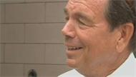
CHARLOTTE – Pro-life activist Flip Benham remains a free man after a judge ruled to not revoke his bond on Friday.
In 2010, Benham was charged and later convicted of stalking a Charlotte-area doctor. He's currently awaiting the results of his appeals hearing and is out on post-conviction release.
On Friday, he arrived at the Mecklenburg County Courthouse ready to be locked up. "That's fine with me. The venue of the ministry just changes and I'm in jail, but it's the same ministry and I'm thankful for that,” said Benham.
The prosecution claimed he violated the conditions of that post-conviction release.
"I never violated the court order. I have obeyed the court orders all the way through. They are saying there were people in Dr. _______’s neighborhood, that Cornelius neighborhood, that passed out brochures. I never went there. I had nothing to do with that, however, they were there," said Benham.
Dr. _______ admits he saw an “Adopt an Abortionist” poster, with his picture on it. He also testified he heard Benham tell a group of people following the appeals hearing, "Let's try to bring Dr. ______ back to God and stop killing babies."
The judge, however, ruled for Benham after it was determined he never received a written order.
"He didn't have that in the order. In fact, he didn't have the order at all telling him what he could and couldn't do. But the restriction of distributing posters, that wasn't in the order anyway, so had he had the order, he still wouldn't have known not to do it because it didn't say that,” said defense attorney David Redding.
Benham left the courthouse a free man. He says instead of from jail, he'll continue spreading God's Word in the streets of Charlotte, for now.
"Sometimes when you keep the law of God, you're going to end up in jail. Most of the New Testament was written from jail. It's just the way it is, and for me not to go out to abortion mills and not to do certain things would be a crime on my part, knowing what I know, to not continue to do it, no matter the cost,” said Benham.
Assistant District Attorney Kristen Northrup responded to this outcome by saying, “While we understand the judge's decision, we are disappointed with the outcome."
The Wizards of Babylon by David Redding (the wonderful attorney God raised up to defend Flip in court)
I was explaining (or trying to) to Marjorie what happened in court yesterday and I showed her the governing statute. She said, "Well, it's obvious." Of course it was. Your rights were not preserved. The judge and the prosecutor did not follow the law, which requires specific conditions and written warnings of the consequences of their violation to be given to you. None of that happened. Truly, you did not know the rules you were accused of breaking. That is why that statute was drawn up. And yet, that judge sat there for five minutes trying to find a way around it before he begrudgingly conceded that he was bound by the law.
His pronouncement of same was mean-spirited and churlish, implying that you had skated by on a technicality. Even when I was an atheist (or a theist or whatever demonic cold hearted thing I was before I knew Christ) I didn't like injustice and unequal scales. But here was a judge, prosecutor, two cops and some seemingly Nice Lady from the Peninsula Community who wanted you in jail despite the fact that you were treated unequally under the law. Their coldness was difficult for me to fathom. It felt dark in that courtroom to me.
We are in Ephesians 4 in my Friday Bible Study, and that morning (before the hearing) I led the discussion about Paul's description of the Gentiles former selves--the ignorance, darkness, hard-heartedness and insensitivity of a people separated from God, whose lives have been given over to sensuality. A people consumed by greed. Paul's implication is one of sexual idolatry, but of course it could be any sensual thing the Gentiles had been given over to.
It occurred to me this morning that Paul's description (perhaps, I know it is not mine to judge) was applicable to the judge et. als. They have given themselves over to a progressive worldview that has hardened their hearts such that they cannot see the irony in the things they say and do.
The prosecutor who would see you incarcerated for advocating on behalf of the unborn was herself at least 5 months pregnant. The Nice Lady testified that it saddened her to see "children" handing out wanted posters was oblivious to the plight of the children destroyed by men whose faces appeared upon them. The Cornelius police officer who testified that his town's entire police force was deployed as a "show of force" when notified about the Peninsula protest could not say why he was ordered to do so. Finally, the judge--the man charged with upholding the law exuded bitterness that it restrained him (just barely) from incarcerating you for exercising your right of free speech. A right so important that our founders enshrined it as the First Amendment to our constitution.
The Truth is a powerful and scary thing Brother. It cuts to the quick. The opposition I encounter to it rarely, almost never, comes in the form of a counter-argument--which is what you would expect from those who think the Truth as I see it is not so. In other words, if those things that comprise our worldview are not Truth, than one would expect a substantive argument from those in opposition.
But rarely if ever is that so. What I encounter in opposition to Truth is generally a demand for silence. That is the best that the opposition can garner when faced with the Truth. Shut up! Be silent! And that is what these cold-hearted people wanted of you in court yesterday. They do not care about your right to speak (and by implication their own right to speak), they just want you to stop because, having no counter-argument to the Truth, they risk conviction by it--and then what?
Thus, the charade that your speech, just your words and the volume at which you say them, is a crime. To them, there is no crime in the legalized homicide of a human being with the bad timing to be drawing breath within rather than without the womb. But to question it? To declare publicly that despite abortion's transient legality it is nonetheless a moral outrage (the precise thing the abolitionists argued in regard to slavery)--that, to them, is a crime so foul that at least two lawyers (judge and prosecutor) were more than willing to disregard the law yesterday, despite having sworn before God that they would uphold it.
It saddens me to say so, but I believe that this charade will never stop as long as there are hearts of stone that seek to resist the Truth by silencing it. Like the Wizards of Babylon they will search for any transgression upon which to hoist you and, finding none, they will fabricate one--if need be. For now, they have the power of the state at their disposal. For now. But we have the Truth. Which do you believe more powerful?

Abortionist Admits Killing – Ugly Black Babies!

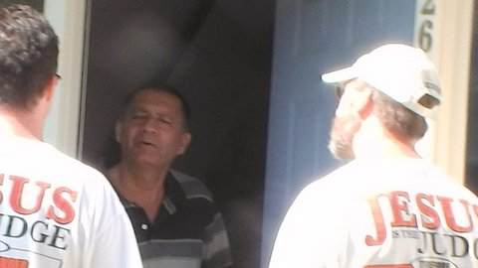
This 38 second video which went viral on the web is incredibly revealing. It was recorded on a neighborhood visit by OSA on July 26th, 2012. Abortionist Ron Vermani of Charlotte, North Carolina, has a problem – now he is giving it to everyone else. Several years ago he was removed from the staff of Presbyterian Hospital in Charlotte because of his shoddy medical practices and record keeping. Upon his removal, he purposed in his heart that he “would not deliver pretty babies anymore.” He has kept his promise in spades!
Upon his request, I visited him three weeks ago at his home. I sat and listened to him attempting to justify himself as to why he kills babies and what causes him to do it. Most abortionists that I have been in contact with over the years always seem eager to justify themselves to those of us out on the sidewalks bringing Christ to moms in crisis pregnancy situations. Abortionist Vermani is filled with bitterness and rage. It wasn’t long before the fusillade of four letter words poured out of his mouth. He called me a racist because I had often said to those entering the abortion mill that he was a bad doctor. Anyone who calls him a bad doctor is a racist.
Why is he filled with such fury and venom? Because he believes Presbyterian Hospital is racist and fired him because of his Indian ethnicity. Because he is divorced and has two children that he doesn’t see much. Because he is all alone now and assuages his deep seated hatred for almost everyone by killing “ugly black babies.” By the way, Ron kills “ugly white babies” too. To his twisted mind, making ugly babies out of the beautiful ones God creates is somehow payback justice for what the Presbyterian Hospital, his wife, and life did to him. Ron Vermani believes he is a victim.
His solution to crime in America is to kill babies. His solution to welfare in America is to kill babies. His solution to rising taxes in America is to kill babies. His solution to stanch the flow of bitterness that fills his heart, is to kill babies. Murder is his answer to everything. Sounds just like the DNC doesn’t it?
Kill the old, kill the new, and kill all those who disagree with you.
Jesus cannot save “victims.” He can save only sinners. As a matter of fact, Jesus is the friend of sinners. Yes, he is a friend to every man who finally comes to the realization of how wretched he really is and confesses this truth to the only One who can save him from his sorry self – Jesus! Ron Virmani desperately needs Jesus.
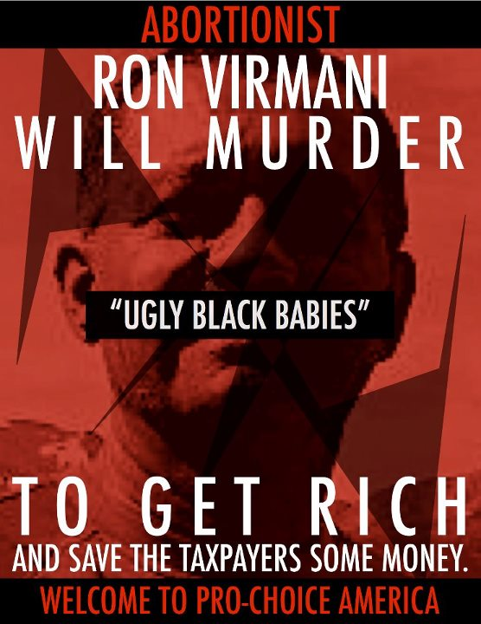
Caught on video: Abortionist talks of the “ugly black babies” he aborts
by Jean McCarthy Mon Aug 06, 2012 13:14 EST
CHARLOTTE, NC, August 6, 2012 (LifeSiteNews.com)
Charlotte abortionist Ashutosh Ron Virmani was caught on camera telling pro-lifers to “adopt one of those ugly black babies.”
Virmani’s comments came as he was speaking with pro-life activists from Operation Save America who confronted Virmani on his doorstep on July 26, 2012.
The abortionist’s comments have riled black pro-life activists. Day Gardner, President of the National Black Pro-Life Union, said in a press release, “It’s all too obvious that he had a particular disgust for black babies and therefore has no problem killing them.”
Virmani defended his practice of abortion as an effort to save taxpayers money and prevent crime. “I as a taxpayer do not wish to pay for those babies to be born and brought up; and kill those people in Colorado,” he said in reference to the Colorado theatre killer.
Notably, the Colorado killer who killed 13 and injured 58 moviegoers was a physically healthy white male born to a middle-class couple.
Operation Save America representatives can be heard on the video saying, “We will adopt them.”
Gardner concluded: “The black community should be outraged because Ashutosh Virmani is a brazen racist and his statement supports what we already know of the billion dollar abortion industry – black babies are targeted because they are seen as poor, worthless and maybe even “ugly.”

Little Rock, Arkansas, September 12-16, 2012. Our next regional event in States of Refuge.

Little Rock, Arkansas, is our next opportunity to allow the theology of heaven to become biography in the streets. There is one abortion mill left in the state of Arkansas. The Church in Little Rock is rising up to the Gospel battle. Soon there will be, “the first abortion free state.” Oh Jesus, “Let it be so!”

It may seem inconceivable to us but it is inevitable with God!

Keep storming the gates of hell in the mighty Name of Jesus! They cannot prevail.

flip

