OSA–CT, August 2012 Stats for Bridgeport
76 babies killed by surgical abortions, 3 babies saved
JESUS’S MIRACLE BABIES BORN IN CONNECTICUT
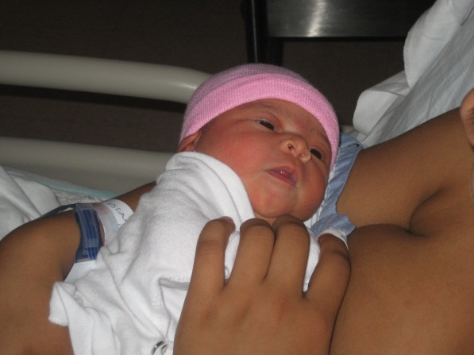
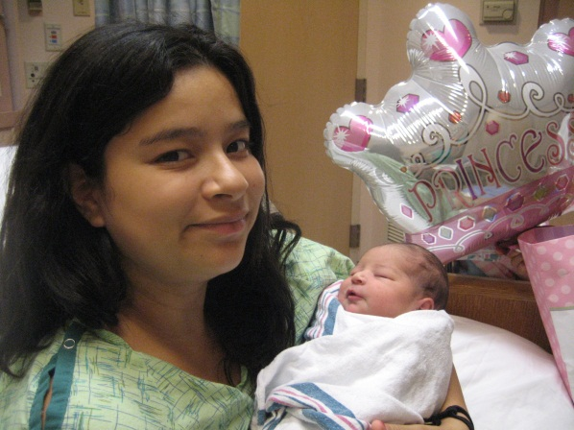
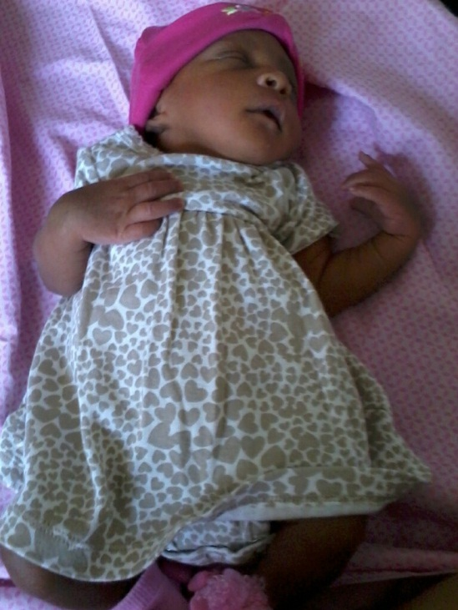
1st picture-- This miracle baby girl was born 8/17/12 at Yale New Haven Hospital.
Her name is Miah and she weighed 6 lbs., 6 oz. We are so excited we get to
see the fruit of the ministry! These are God's image bearers. PTL
2nd picture-- This is a 17 yrs. old mom who had her precious baby girl at St. Vincent's
Hospital on 8/20/12. The baby's name is Esmeralda and she weighed 8 lbs., 4 oz. The doctors
were surprised that she weighed 8 lbs they expected a smaller baby! She is beautiful.
3rd picture- This is Janel, she was born at St Vincent’s Hospital on 8/25/12. She weighed in at 6 lbs. 5 oz. Her parents are very humble and appreciate the things we have given them.
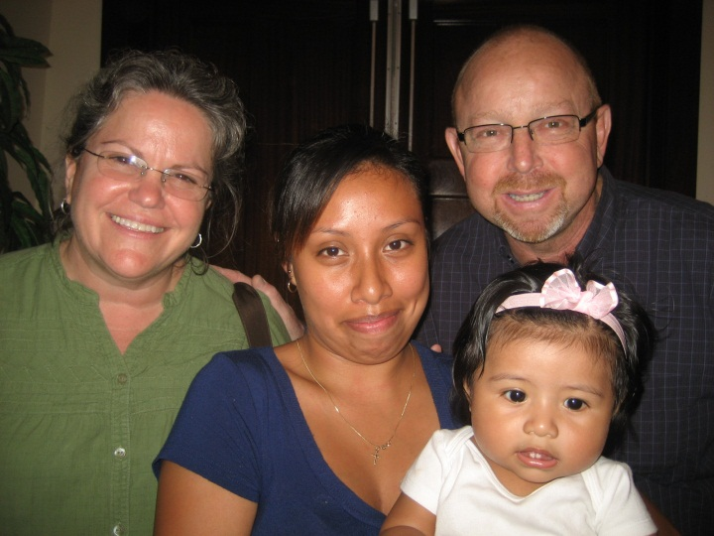
This is one of the moms that was having family issues at home and she
called crying for help since her parents told her she had to move out. Carmen called Joe
and Nancy Leta a couple from her church that volunteered to help us by opening up their
home to moms in crisis. They were such a blessing to this mother and her baby girl Ginelly.
They discipled her and brought her to church. With the Lord's help this mother was able to go
back home after two weeks and reunited with her family again. We thank God for the body of
Christ that we can work together in time of need. To God be the glory!
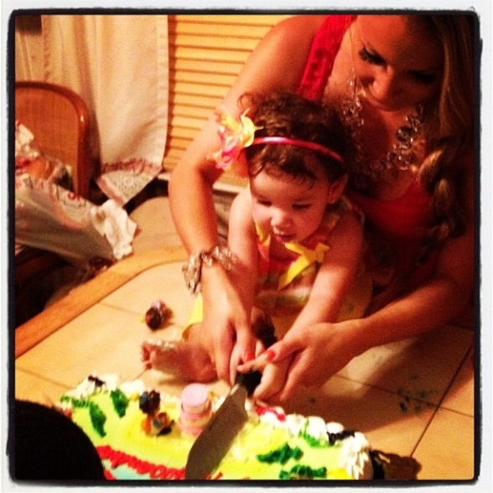
Alesandra had her first birthday August 3rd. PTL!

Shaylah (18 on Aug. 27th) and AJ (2 on Aug. 10th ) are at Wilson College in Pennsylvania. Shaylah received a full scholarship for her and AJ to go there. She was Valedictorian of James Hill House Family High School senior class this year and also a Gates Millennium Scholar. She is not ashamed of the gospel and a firm believer in the Lord Jesus Christ.
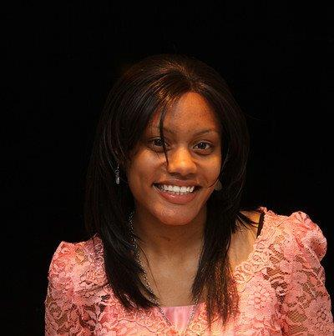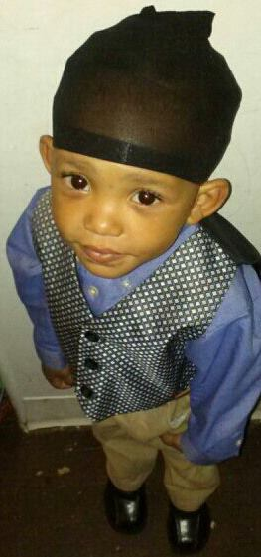
Shaylah’s prayer: “Jesus your love is ineffable-unconditional-merciful Lord Redeem the time even longer for this corrupt generation. Continue to send your sweet and strong spirit so that we can withstand the trials and temptations by the evil one. Thank you for blessing me even in my distress and despair; your grace is sufficient. It’s all in your hands Jesus...not my battle. O Kinsman Redeemer, Jehova Shalom! I war cry for my friends, foes and strangers. Lord keep them because they too have eyes to see and ears to hear your word so that they can live blamelessly! Please, humanity NEEDS YOU!!!”
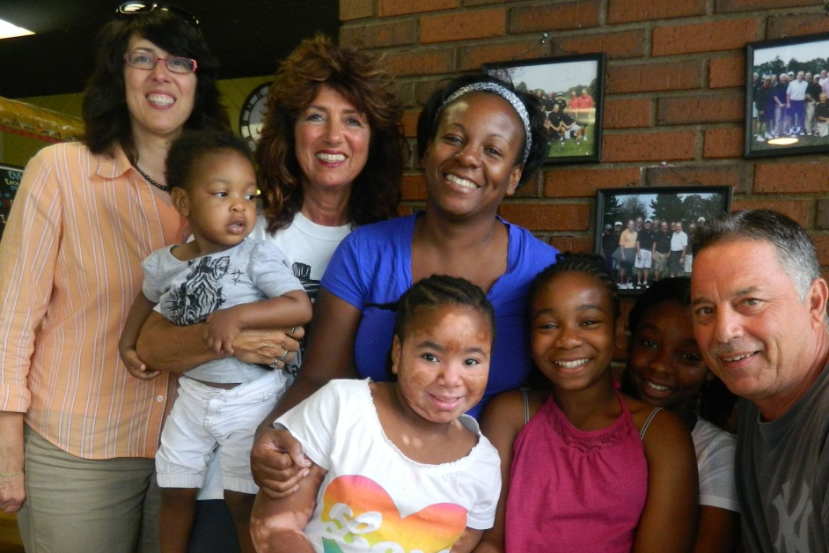
We pray God’s best for Fara, Corey and children with their new move to Franklinton, NC. They have been a precious part of our ministry for the past 21 years. We love them and pray for them always.

“He who is kind to the poor lends to the Lord, and He will reward him for what he has done.”
Proverbs 19:17
I want to thank April McMillan from my church, Calvary Life, in Cheshire for taking two of the pregnant moms to church and delivering needs to them. Please pray for Frances and Soly’s walk with the Lord to grow. Pray against hindrances. They are reading their bibles and really love church!
Good news : The Summit Women’s Center in Hartford has closed! This is the sister clinic to our mill. Now we pray that the Summit Women’s Center in Bridgeport will close too. We need your prayer presence here at 3787 Main St. Bpt. on Tues. Wed. Fri. Sat. 8-10 AM. Come and see what God will do! He will save lives and souls through your efforts. He just wants a willing body to be His voice, His hands, His feet. He is the Head and we are the Body of Christ. If not us-then who? If not now-then when?
PRAYER REQUESTS: please pray for Fr Francis McCloskey in New York. Nancy, Tom and Daniel went to see him at the convalescent home where he is suffering from Alzheimer’s disease. Fr Francis is a friend of the babies and did many rescues to save their lives. We were involved with him at many “Oh Saratoga! “ events in New York and he came here to CT for many of our prolife activities.
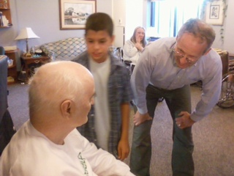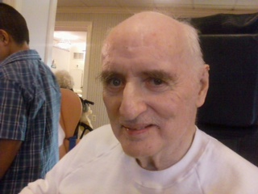
Also please pray for Terry Helfrich, one of our co-laborers (who adopted five children years ago). She had open heart surgery and was away from home for 54 days! She had to go back to the hospital three times by ambulance from the nursing home. They had to give her a pacemaker. I spoke with her and she said she doesn’t feel like herself. She has had months of discomfort and expects more. Her hands are swollen too. Please pray for her. Jesus is the Great Physician and nothing is impossible for Him!
NEEDS: 2 dressers, boy clothes size 6-7 , diapers 2-5, wipes, food cards. Donations can be sent to: OSA-CT, 632 Merwin Ave Milford CT 06460-3820. Giving is at its all time low and we need resources to help these moms. We promise to help Moms if they keep their babies and we must keep our word. We are the frontlines four days a week pleading with moms planning to abort, can you be our supply line? We can’t do this alone. Last month we had a grandmother send us two five dollar bills. She is poor and takes care of her five grandchildren (one of them is a saved baby) I consider what she gave “the widow’s mite” and was humbled to receive her offering. No donation is too small or too big.

