October, 2012
States of Refuge – Little Rock by Rusty and Kendra Thomas
"Therefore rejoice ye heavens, and ye that dwell in them. Woe to the inhabiters of the earth and of the sea! For the devil is come down unto you, having great wrath, because he knoweth that he hath but a short time." Revelation 12:12.
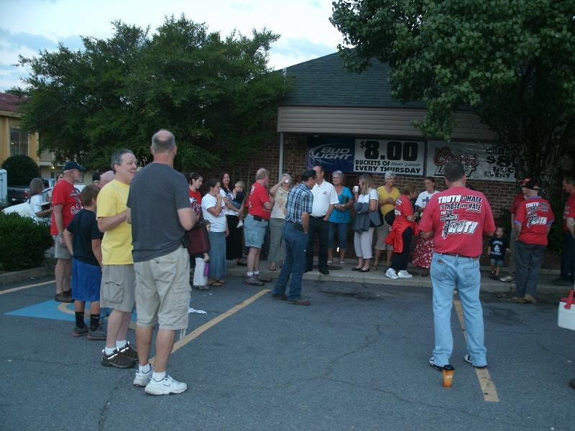
As we prepared to go back to Little Rock, Arkansas, as a part of the States of Refuge campaign, we expected the battle to establish Arkansas as an abortion-free state would escalate. Indeed, it takes a village to kill a child and the city of Little Rock has many tentacles that prop up and insulate its last remaining death camp. Sadly, abortion has entrenched itself through the silent consent of God’s church. In addition, the "nicer than Jesus" pro-lifers who shrink from preaching the Word of God at the clinic have strengthened the powers of darkness that jealously protect child killing –the shedding of innocent blood. They are too kind to proclaim God’s Truth!
- Preparing for day
Two men of God, Pastor Mark Holick and Ron Duhe, were arrested on a public sidewalk at the death center. At first, there was confusion over the charges. Were they arrested for lack of a permit or was it a violation of a sound ordinance? I believe they finally settled on charging them with disorderly conduct. A local lawyer with Alliance Defending Freedom has taken the case. She is perplexed by the police department's handling of her clients, their arrests, and the stonewalling she experienced while representing them.
We are hopeful that officials will drop the charges and our brothers found innocent. Rest assured, this city will be held accountable by God for this injustice. It will learn the hard way that we are not the troublemakers and the disturbers of the peace. In 1 Kings we read how King Ahab, the civil authority of Israel who supported child sacrifice, called the prophet Elijah, "the troubler of Israel." Elijah corrected him, "I have not made trouble for Israel, but you and your father's family have. You have abandoned the Lord's commands and have followed the Baals." It is Little Rock's death camp that is troubling the state of Arkansas and disturbing its peace. Shed blood in the womb and you will reap it in the streets – Hosea 4:2.
Before Pastor Mark was arrested, he was spat on by the security guard as he was trying to persuade couples to choose life. Interestingly, this was the first time the abortion mill brought in deathscorts with signs and umbrellas to "protect" deceived parents from hearing the truth that might spare lives and save souls. Clearly, the city government and death camp were on edge. They were highly agitated and full of fury. We pray that this is an indication that the time for this abortion mill is short – that Arkansas will become the first abortion free state.
Opening Rally: The States of Refuge Little Rock event opened Wednesday evening at Redeemer Community Church. This was a miracle of sorts. Another church, which volunteered to host us, had to withdraw right before the event. Obviously, this left us in a predicament. As we have found in every city where we have set our foot, though we plan our way, the Lord always directs our steps. Thank you Jesus!
That night we laid out the vision for the event and for the States of Refuge campaign. The main message preached that night was The Tale of Two Governments. At the end of the rally, our marching orders for the next day's activities were given.
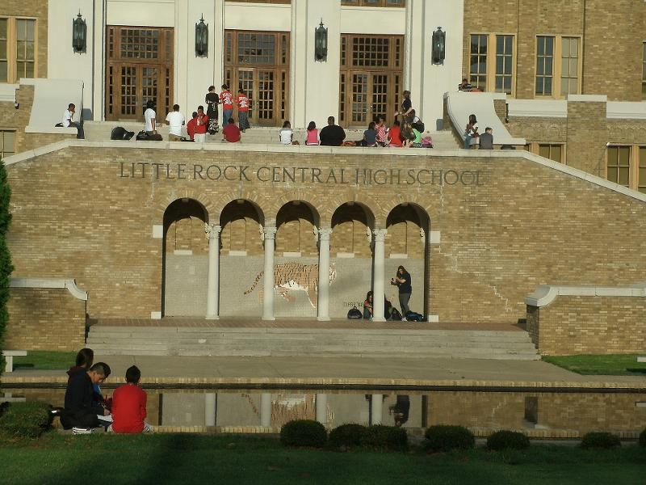
Day One: The saints gathered at 6:30 AM to hear instructions from God's Word from Rev. Flip Benham. He was preaching from Isaiah, which correlated with the OSA Bible Reading Schedule. Throughout the week, Rev. Flip went back and forth from the prophets Isaiah and Jeremiah to challenge the saints to consider how they were going to vote in the upcoming critical election. Though he never did tell anyone who they should vote for, he did put this election within the Biblical context found in Jeremiah.
“Thus says the Lord of hosts, the God of Israel, to all who were carried away captive, whom I have caused to be carried away from Jerusalem to Babylon: Build houses and dwell in them; plant gardens and eat their fruit. Take wives and beget sons and daughters; and take wives for your sons and give your daughters to husbands, so that they may bear sons and daughters-that you may be increased there, and not diminished. And seek the peace of the city where I have caused you to be carried away captive, and pray to the Lord for it; for in its peace you will have peace.”
Jeremiah 29:4-13
Flip taught that our nation is under the judgment of God. Our land has been handed over to enemies that now rule over us. In times such as this, we are to pray, live, and vote with this understanding. We should seek the peace and prosperity of our beleaguered nation, so we may have a possibility of peace and prosperity. What candidate would give us the greatest opportunity to proclaim the Gospel of Christ in the streets of America?
Ministering the Gospel at Central

We sent one small team to the death camp to lift up the name of Jesus, preach the Gospel, and provide a choice for parents that would lead to life – not death, and blessing – not curse. The clinic was open on Thursday, Friday, and, thank God, closed on Saturday. Typically, Saturday is the busiest killing day at abortion mills. We know of four babies saved and witnessed two turn aways. There may have been more that were spared the horrors of abortion, but that is what we know for sure.
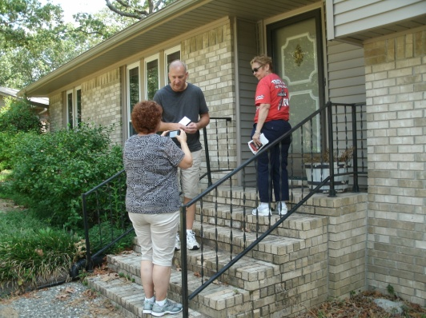
The majority of the saints went to Central High School armed with signs, literature, and the love and truth of Christ. We passed out tons of tracts, witnessed one-on-one, and preached to the students who congregated outside.
Another team went to the neighborhood of the clinic manager who has worked at this death camp for 25 years. A week before this excursion we sent out a flyer to about 900 of her neighbors, exposing her participation in the hidden works of darkness. This time, however, the saints went to her home and neighborhood to complete our witness.
Afterwards, we returned to the clinic to "give them heaven" until it closed. We concluded the day with our evening rally at Redeemer Community Church.
Day Two: We gathered together at 6:30 AM again at our staging area. One smaller team went back to the clinic, while a larger team went to another high school. It was North Rock High School. One incident in particular personally blessed me. It happened when I challenged a group of young men to receive our tracts. Most of them stayed where they were, others hesitated, but one young man instantly came. His name was Mason. Mason is a Christian who is not ashamed of the Gospel of Jesus Christ. He boldly stands for His Lord. His testimony brought tears to my eyes. He not only took the tract, but asked for copies to pass out. We discussed the fact that Jesus, the Gospel, God's Word, and abortion would be the topic of the day in his school. I challenged him, and others that named the name of Christ, to seize the opportunity and muster the courage to contend for the faith in their school. They promised they would.
Praise be to God!
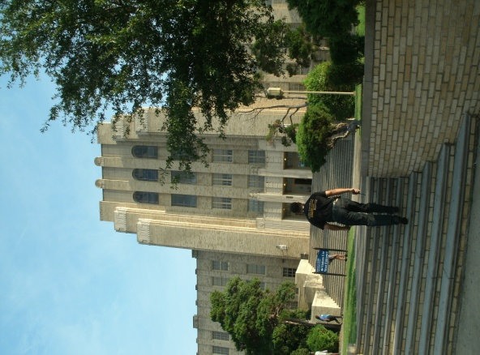
Afterward, we split up. One team went back to the deathcamp, while Tom Raddell set up his magnificent display at the University of Arkansas, Little Rock. The day before, they denied us access. That conversation, however, was caught on video. Thankfully, they reconsidered their denial of our Constitutional rights and invited us back to their campus. There were hundreds of divine appointments and open doors for ministry.
Mosque Outreach: "For by grace you have been saved through faith, and that not of yourselves; it is the gift of God, not of works, lest anyone should boast. For we are His workmanship, created in Christ Jesus for good works, which God prepared beforehand that we should walk in them" Ephesians 2:8-10.
North Little Rock High School guard thanked us for coming
The Mosque outreach on day two deserves its own special mention, especially in light of the recent attacks against our embassies abroad. Typically, when we go to mosques to present the Gospel of the Kingdom, we set up outside, pass out literature, hold signs, and preach from a sound system. This time, we actually went into the mosque to observe their service. To save space, this brief video presentation highlights what happened as men of God confronted this false religion with the Gospel of Christ.
Day Three: The saints gathered at our staging area in the morning at 7:30 AM. We were met with a rainy, stormy day. Tom Raddell was scheduled to set up his display at a huge farmer's market, but this was cancelled due to the weather. Regardless of the down pour, God's mail still had to be delivered so a team of us went to the neighborhood of abortionist Tom Tvedten.
We passed out flyers in his neighborhood and throughout the town. He lives in Heber Springs, which is about an hour and a half away from where he applies his grisly trade. It appears he is trying to conceal a double life and to distance himself from his grave evil. We are preparing a follow-up mailer for the entire Heber Springs community. There will be no tranquility for those who murder God's babies for blood money.
As I write, there is another Christian/Prolife ministry preparing to come to Arkansas next week to set up a Truth Tour. They will be there for a week. They will go to universities, high schools, busy streets, and the death camp. This helps to create the wave after wave impact we planned for the States of Refuge campaign. Brethren, continue to stand with us in prayer, labor, and financial support as we seek to offer God the first abortion-free state in America.
Twin Babies Saved by Brenda Spurlock
Thursday, 9-13-12, our first full day of life-saving activities in Arkansas led off with a return to historic Little Rock Central High School, site of the 1957 school desegregation. Security guards herded bus students quickly past us and school officials took away any OSA pro-life literature they'd been handed. What if one of these teenagers was pregnant and had the opportunity to read the truth about abortion from our pamphlet? What if, because she was informed, she changed her mind and let her baby live, saving herself from a lifetime of guilt and shame before the Lord?
Praise God! He allowed some of our OSA team members to see the "what ifs" unfold in a glorious way Friday morning. A young couple, students at Little Rock Central High School, pulled into the drive at Abortion Access Family Planning. Ruth Darr was there waiting for them. She told them she would help them with anything they needed. Ruth asked the girl (I'll call her Dee ) if she'd had a pregnancy test. Dee said "Yes, but only a drug store test. I came to get a 'real' pregnancy test." She said they'd told her at the abortion mill that she needed a pregnancy test from them. Ruth assured her the drug store test was just as accurate as any test they could give her. "They lied to you to get you in, so they can abort you," she told her.
When Ruth verified that Dee had not had other children, she informed her there is a 50% increased risk of breast cancer if you terminate your first pregnancy. This captured the couple's full attention and may have been a turning point for them.
Dee was concerned that her mother would not accept a baby. She said her mom didn't like children. When asked if mom had any grandchildren, she said "No." "Then she'll love being a grandmother!" Ruth said. But, because of Dee's doubts about her mother's acceptance, and because she might need a place to live, Ruth contacted a local pro-lifer who put her in touch with Promise House who offers housing to pregnant teenagers. Promise House had an opening and Dee can continue attending L.R. Central High School.
When the Crisis Pregnancy Center opened, Dee had a sonogram with results that amazed everybody. "There's two!" she told Ruth. That's right, twins! Ruth said, "I felt like a new grandmother!" God is so good! His rewards are more than we could imagine or hope for when we are obedient to His word.
The University of Arkansas at Little Rock by Mike Warren
This University is home to over 13000 students and part of the publicly funded Arkansas university system. After being assured by campus security that there should be no problem setting up a pro-life display, “All kinds of groups are constantly setting up displays,” said one campus security guard; we met stiff resistance from the university’s administration as we notified them of our outreach. The, “Anything, but this” response.
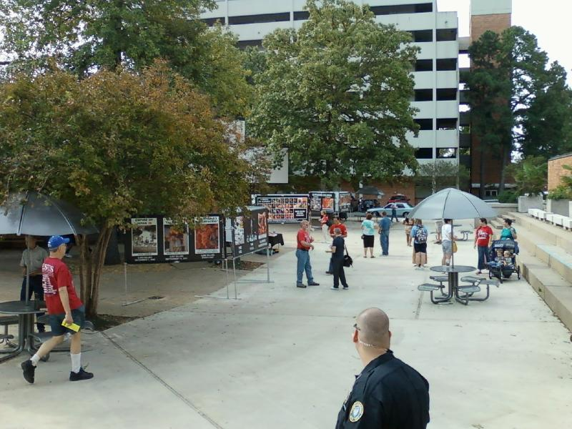
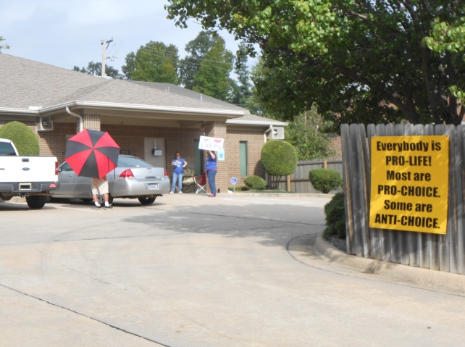
Our distribution of the DVD180.com and the use of graphic aborted baby pictures in The Justice for the Unborn display were deemed to be too offensive and any material that dealt with the Nazi holocaust would definitely not be allowed. This display has been used in four of the five states that have hosted a States of Refuge Outreach and officials from the university seemed intent on censoring its use on their campus. Officials were adamant that any literature or display of a graphic nature or that dealt with the Holocaust was not going to be allowed.
This was before they learned that the conversation we had with their officials and their objections and reasons for denying us access had been digitally recorded. Then we were given permission and smiles! This allowed us to speak for the babies who cannot speak for themselves and connect the dots regarding historic acts of genocide and the current genocide that is practiced by Planned Parenthood and the abortion industry. Hundreds of pieces of literature and many 180.com DVDs were distributed.
Next States of Refuge Event – Jackson, Mississippi, November 7-11, 2012
We pray that you are planning to join us in Jackson Mississippi, as Chet Gallagher will be heading up this event. The vision that we are imparting to the Church of Jesus Christ in all five of our States of Refuge is that abortion is an issue that only the Church of Jesus Christ can fight and win. This is because abortion is a Gospel issue and the gates of hell cannot prevail against God’s Church. They will, however, forever prevail against any political party, President, Supreme Court, or Congress. We were born for such a time as this – REJOICE!
Keep storming the gates in Jesus magnificent Name! Flip

