The saints in Orlando have been very active since the OSA 2011 event. I went with them on a Saturday morning for a neighborhood awareness campaign in Winter Park where Jenna 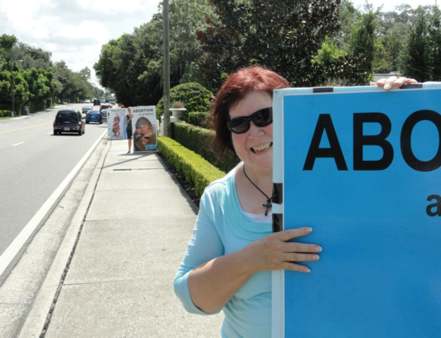Tosh the new CEO of Orlando Planned Parenthood lives. I guess Jenna was not as proud of her profession as she claims because she had a hissy and called the police who found that we were peaceful and left. Then she whined to the city council and they passed an ordinance labeled “for peace and tranquility.” Both pro-lifers and pro aborts testified at the hearing and the “no picketing” ordinance passed with only the mayor voting NO! Interestingly enough, the mayor commented that he was voting against the ordinance because he had 1st amendment issues and that he felt the ordinance would bring “neither peace nor tranquility to the city.”

R.C Sproul Jr spoke eloquently giving them Jesus amid interruptions from council members stating they did not want to hear about abortion. Each time he paused, smiled and continued with the same massage. It was a pleasure to hear. Deanna Waller, Allura Lightfoot, Jay Rogers, Michelle Herzog and many more gave them heaven even if they closed their ears and hearts. What a joy it is to be among such “giants in the kingdom.” When I spoke I ended with a paraphrase of Psalm 127:1 saying “I noticed you are trying to build a beautiful city here, be very, very careful, the Bible warns that if the Lord does not build the city the builders build in vain!” Of course I was misquoted in the paper – I think it was the mention of the Bible that scared the reporter.

One speaker in favor of the ordinance is worth notice if only to show the idiocy of pro-aborts. A lady who was obviously angry and pacing when pro-lifers spoke, got up and asked if she could show something on the screen. We were all expecting she would display one of our “adopt an abortion worker” flyers – no – she put up a Starbucks ad and talked about everything but the ordinance - donuts, street signs etc. When asked to stick to the topic she exploded and pointed to us saying “They should all be shot – they are killers – they bomb places.” Then she went back to advertizing cookies and donuts –bizarre! Even the police gave her a wide berth when we exited the chambers.

Yes- we are challenging this ordinance and have had multiple offers to represent us. We are talking to lawyers now. The following is the Orlando Sentinel (lopsided) story. But then what should we expect from a liberal rag.

By Anika Myers Palm, Orlando Sentinel
8:51 p.m. EDT, September 24, 2012
Winter Park has officially adopted an ordinance that its City Commission thinks will protect residents from protests in residential areas.
On Monday night, commissioners voted to ban residential picketing targeted at specific homes within city limits. The council proposed the ordinance after an August protest outside the home of Jenna Tosh, the CEO of Planned Parenthood of Greater Orlando. Violations of the ordinance will be considered a misdemeanor.
"Regardless of the profession of the targeted person, this most crude form of harassment doesn't belong in our city," said Vice Mayor Steven Leary.
Mayor Ken Bradley was the only member of the commission to vote against the ordinance, citing First Amendment concerns.
About 20 people spoke during the public hearing portion of the meeting. About half, mostly residents, were in favor of the ordinance. Several people, including a few anti-abortion rights activists who do not live in the city, said the ordinance was a violation of the free-speech rights of protesters.
David Slaughter, a University of Central Florida legal studies professor, read from a similar legal case and encouraged the commission to consider other similar ordinances that he said were constitutional.
"No one is to be subjected to objectionable speech in the privacy of their own home," he said. "It's about having the right to be in your own home and not have unwanted speech forced down your throat."
The activists and their supporters, however, said the ordinance would put the city on a slippery slope toward violating the First Amendment and banning other kinds of free speech.
"You're trying to build a beautiful city here," said Dr. Patricia McEwen of Doctors for Life International. "Be very, very careful because a big court battle over this would not help your city."

