Operation Save America – CT
Moms come back to show their gratitude! What an encouragement to us!
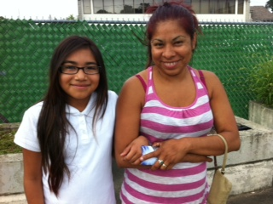
Mom (Alma), with daughter (Christina), who is now 10 years old.
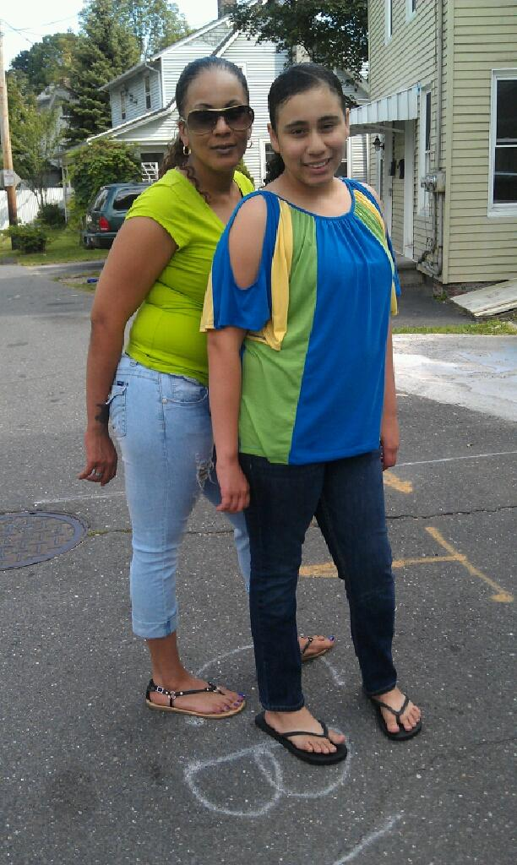
Mom (Carmen) with daughter, who is now 12 years old.
Moms are always stopping by in Bridgeport to tell us how grateful they are that someone was there to help them choose life for their children. These both are so blessed to have their daughters in their lives. One of them wants to start going to church with her family.
Just in the last two weeks: Two moms rode by blowing love and kisses to us out the window.
Another mom came to breakfast with us and said she is forever grateful that we were there for her during a very difficult time in her life and she will never forget it.
Another mom came and showed us her baby saying we help her more than her family.
Another sent a Facebook message saying “You both are very special because you are one of the reasons my baby girl is here today, along with God and my family. I would love for us to get together. She is running now, she says words, she’s amazing, she hugs and kisses me, it’s unbelievable. I couldn’t picture my life without her! “
Another texted and said “I am praying all the time and I read the Jesus book to my boys. I want to bring them to church with me. Lately I have been listening to God and know He has something good in store for me. I don’t know where we would be if we didn’t meet you.”
Another mom wrote a paper on Planned Parenthood in her college class and how she met us on the streets and saved her baby’s life. Now she loves him so much and he is her life.
Others came and called thanking us for the things we get for them.
We tell them it’s not us, its God! He is the Head and we are His body, the Church. We are His mouthpiece, His hands and His feet on this earth. It’s our pleasure and honor to do His work. We can’t do this alone, we are the frontline and we have a supplyline helping us (that’s all of you).
No matter how you help: in prayer or in giving material things, or in your presence at the mill, it all works together for good for those who love Him and for those who are needy.
September 2012 Stats: In Bridgeport: 46 babies killed by surgical abortion and 6 babies spared from abortion. They also do chemical abortions (morning after pill, oral contraceptives, patch, injections, etc) and medical abortions (up to 7 weeks) RU-486. In New Haven at Planned Parenthood on Saturdays in September it appears that about 111 women went in for abortions. Since 1990: 2236 babies have been saved and 406 salvations. All the glory goes to God who allows us to co-labor with Him!
On Sept. 28th we meet a Muslim couple that was going into Summit. We had an opportunity
to talk to them extensively before they went into the parking lot. The young woman wanted to
have the abortion but her husband had his doubts. We encouraged them to trust the Lord and
reminded them that Muslims don't murder their babies. We were able to give them the book of
John & Romans with a DVD of the life of Jesus in their native tongue. They were very open
and the man started to cry as he was convicted about the abortion and his wife started crying
also. The Lord moved on their hearts and they never went inside the mill! PTL We were able to give
them the Eclipse of Reason DVD that shows the procedure and they took it home with them.
We called them the next day and the husband said he and his wife watched the video and
they were mortified at what they saw. They are keeping their baby and this is their
fifth child. He was so grateful that someone was there to talk to him and his wife. We are so
touched by how humble this man was and how lost he is without Christ. It reminds us of what
the scripture says "I will turn the hearts of the fathers to their children". We'll be staying in touch
with this couple and ask everyone to pray for couples like these that are so blinded to what abortion
really is and who the true God is.
“The wages of sin is death, but the gift of God is eternal life through Jesus Christ our Lord,” Romans 6:23
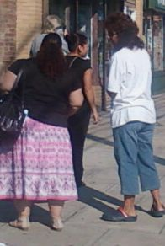
In the picture above Marilyn is talking with Madeline, who we know from the bus stop near the Summit. When this Hispanic mom was going into the mill, she translated for us in Spanish and the mom changed her mind. Madeline is drawing closer and closer to the Lord and she was so excited to play a part in saving this baby’s life. God even uses the bystanders on the streets to minister for Him!
“All those who hate me (God’s wisdom, love death.” Proverbs 8:36)
“And have no fellowship with the unfruitful deeds of darkness, but rather expose them.” Ephesians 5:11

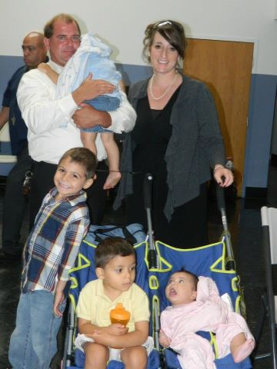
Here is Ron and Brenda with their crew they’ve been taking care of for the last five months. The four children have adjusted well and now say “I love you” to them. Their son, Brodie, has been such a blessing helping out with the children and is very protective of Baby Brenda. Please keep them in prayer and for the biological parents for salvation and stability. The Rutherfords still need a van to transport the family together. When they go somewhere now they need two cars and two drivers. If you know of any vans available for a reasonable price please let us know.
October 18th, Dr Alveeda King, Martain Luther King Jr.’s niece, will be speaking against abortion and black genocide at St Theresa’s Church on Main Street in Trumbull. For more info contact Nancy at: nancyfitness@att.net
NEEDS: Furniture: 2 dressers and a couch Diapers: Sizes 1,2,3,4,5 and wipes
Housing: a couple needs housing in Bridgeport; they have a two year old daughter and twins on the way.
Jobs: a couple in Waterbury needs jobs. The mom has been a CNA but will do anything she can. The father has been a sales associate, cook & cashier; he will do whatever he can too.
Clothes: Girls: size 6-7 pants, leotards, size 3-4T, Boy: Size 5 & 9-12 months, Children’s Coats: all sizes
Donations can be sent to: OSA-CT, 632 Merwin Ave Milford CT 06460-3820
Report by: Marilyn Carroll and Carmen Vazquez, www.osaconnecticut.webs.com

