**March 2013**

**Invitation to OSA National Event, July 24th -31st, Rochester, N.Y.**

Dear Brothers and Sisters in Christ: Jerry Crawford and I are delighted to extend an invitation to you and yours to join us in contending for the Gospel of our Lord Jesus Christ and for Life in Rochester, NY this July 24-31st. For forty years the American Church has wandered in the wilderness, seeing a rise of Godlessness and 55 million children destroyed as a result of the United States forsaking our Biblical heritage and foundations.  Yet the promise of Isaiah 60: 1-3 rings true.  *“Arise, shine, for your light has come, and the glory of the Lord rises upon you.2See, darkness covers the earth and thick darkness is over the peoples, but the Lord rises upon you and his glory appears over you. Nations will come to your light, and kings to the brightness of your dawn.”*

Could it be that OSA Rochester, NY will mark our passing through the Jordan and into the promised land of renewed hope, renewed righteousness and restoration? Come and be a part of what God will do! Rochester has been the site of historic revival during the C. G. Finney’s ministry in the mid 1800’s. Rochester was a vital station on the Underground Railroad and the home of former slave, freedman, abolitionist leader, and Christian, Fredrick Douglass. It’s time for the church to arise and contend again! It’s our turn now!

Mike Warren and Jerry Crawford, Rescue Rochester

**Update from Mississippi** by Cal Zastrow

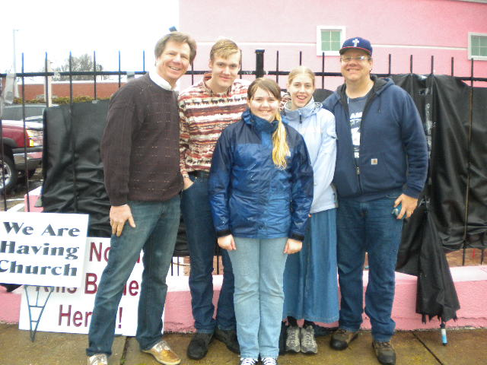What does an abortuary do when they are losing money from fewer moms murdering their babies?  How do they cope with so much praying and preaching on the sidewalks surrounding them?  When the Department of Health revokes their license and prepares to shut them down; when the Governor and some pastors declare that they are taking steps toward that end, what is a deathpit to do?   The last remaining surgical baby-killing center in all of Mississippi, The *Jackson Women's Health Organization* (JWHO), handles their problems by pepper-spraying Christians and applying pink paint to their property.  Some are calling it "Pepto Bismol Pink," while others would describe the color shade as "Pig's Ear Pink."  (Folks in Mississippi know that you can't make a silk purse out of a pig's ear.) This black & white picture does not do justice to the ridiculous “pig’s ear pink” so please use your imagination.

April 4 will be the arraignment for Roy Benjamin, the security guard who assaulted a small group of peaceful Christians with pepper-spray on January 23rd.  Instead of being charged with what he actually did “aggravated assault of a minor,” he will be charged with "simple assault."

Since early January, Mississippians have been having Church on the street daily in front of the mill.  They will continue to have Church every Sunday afternoon and on the three days each week that the mill is open.  More pro-lifers are coming out to the sidewalks to minister.  For the last 12 years, Pastor Matt Friedeman has led *Dayspring Community Church* in ministering weekly at these gates of hell. Four new pastors have begun preaching on the streets, and more are returning who have helped in the past.  The photo above is of former Director of Operation Rescue, Keith Tucci with Cal Zastrow and three of his children (Jimmy, Eva, and Corrie).  The Zastrows are daily storming the gates of hell in Jackson with the saints of Pro-Life Mississippi.

The Mississippi Department of Health has revoked the license of JWHO, but JWHO is still murdering babies while they appeal.  More Mennonites and Methodists, Presbyterians and Pentecostals, are now standing up for Jesus and the babies in front of this killing place.  God is blessing the repentance and obedience of faithful Christians who are showing up to trust God to make theirs the very first State to close down all of their surgical abortuaries.   Six have already been closed.  Only one left.  Let's trust God and go close it.  While the culture of death angrily sprays pepper and splashes pink paint, the Zastrows and Pro-Life Mississippi are shouting REVIVAL and peacefully pushing to become the first State to protect every preborn baby, by love and by law.

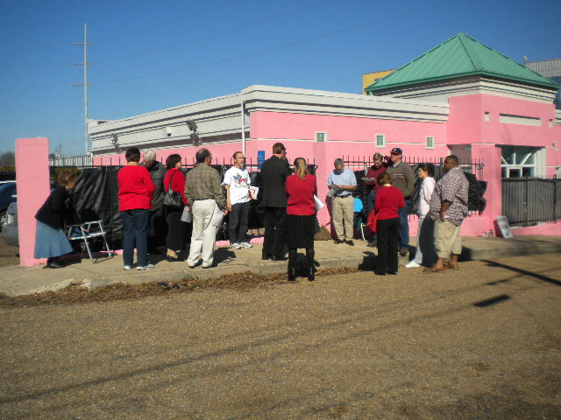**Noose is Tightening on Mississippi’s Last Abortion Mill**

This report from the *Clarion Ledger* in Jackson, Mississippi, is another evidence that, as the Church of Jesus Christ continues to storm the gates of hell, they will not and cannot prevail.  Mississippi is so very close to becoming the first abortion free state in America.  Once the first domino tips they all will come down.

Although the b& w photo does not show it well – clinic is now “pigs ear pink!”

**“For the Word of God is living and active.  Sharper than any double-edged sword, it penetrates even to dividing soul and spirit, joints and marrow; it judges the thoughts and attitudes of the heart.  Nothing in all creation is hidden from God’s sight.  Everything is uncovered and laid bare before the eyes of Him to Whom we must give an account.”  Hebrews 4:12-13.**

**“For though we live in the world, we do not wage war as the world does.  The weapons we fight with are not the weapons of the world.  On the contrary they have divine power to demolish strongholds.  We demolish arguments and every pretension that sets itself up against the knowledge of God, and take captive every thought to make it obedient to Christ.”  2 Corinthians 10:3-5.**

**“Abortion Clinic Gets Letter – Revocation Process Begins!” Clarion Leger 1/29/2013**

Mississippi’s sole abortion clinic is out of compliance with state law and its license will be revoked, according to a letter the clinic received Friday from the state Department of Health. The letter confirms findings from a January 16, 2013, inspection of the Jackson Women’s Health Organization during which Health Department officials noted some of the clinic’s physicians lack hospital admitting privileges.

A state law passed last year mandates that all abortion providers at a clinic have hospital admitting privileges. Despite a month’s - long effort to comply, the clinic wasn’t able to do so. “This is what we expected,” said clinic owner Diane Dersiz, who said the clinic will request an administrative hearing to fight its license revocation. It has 10 calendar days to make the request to the Department of Health. Afterward, the department has 30 calendar days in which to set a hearing, said department spokeswoman Liz Sharlot.

The hearing will be open to the public and conducted by a hearing officer appointed by the department. The officer may or may not issue an immediate decision, Sharlot said. If the decision results in license revocation, the clinic then can appeal to the Chancery Court. In the meantime, attorneys for the Jackson Women’s Health Organization want a federal court to issue a temporary injunction to block the law’s enforcement while it argues its constitutionality. U.S. District Judge Dan Jordan has yet to rule on that request. Without an injunction, the clinic could be forced to close in March after having exhausted all other options, according to the New York-based Center for Reproductive Rights, which is litigating the case on its behalf.

**Islamic Inroads – The Same “god” Just Different Names!**

Michelle Sochia took this picture of a bumper sticker she saw in New Orleans. Incredible, yet so typical of Islam to desire to be ChrIslam and prostrate Christianity to the level of all other false religions, including itself. The "jesus" of Islam and the "gospel" of Islam is a heteros (different) gospel which is really no Gospel at all**. 2 Corinthians 11:1-4; Galatians 1:6-9.**

The "jesus" talked about in the Qur'an is not the Jesus of the Bible. There is no way that Christians should tolerate this nonsense. The Qur'an states that Jesus did not die on a cross, that He is not raised from the dead, and that He is not God. The Apostle Paul tells us that if Christ is not raised from the dead then our “preaching is in vain and our faith is futile.” 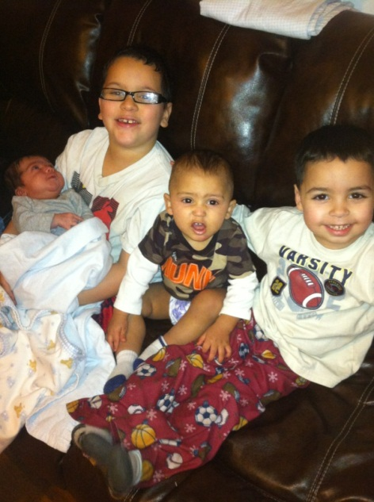Let the redeemed of the Lord say so! **1 Corinthians 15:12-20.**

Surprise for all searching Muslims! Jesus did die on an old rugged cross for your sins and mine. He was raised from the dead. He is seated at the right hand of the Father. And He is (let the reader understand) Almighty God Himself. Apart from Him there is no other – this includes allah and his false book.

**God Gives Saints In Connecticut a New Bakery!** By Marilyn Carroll

Not only did they get a new bakery but they had two babies saved in January.  Here is the Connecticut January report of what God does when His saints allow the theology of heaven to become biography in the streets. A precious baby boy JoJuan was born Sunday, February 3, 2013. He weighed in at 8lbs, 10oz. His mom is so grateful that we were there when she went to Planned Parenthood on June 2, 2012, and helped her to make the right decision for life! She has been amazed at all the love she has received from the body of Christ. The photo is of one of the saved babies, Nathan, now two and a half months old. His brothers love him so much and so do mom and dad. He has made their family so blessed because he is here.

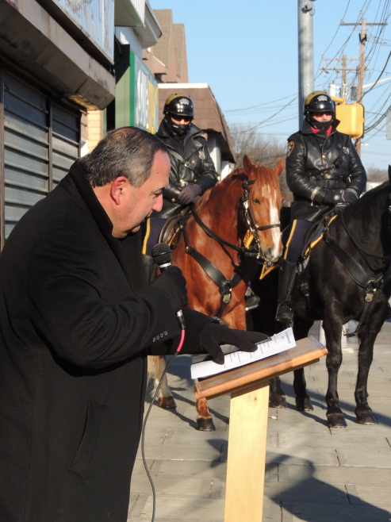We had a blessed time in Jackson, Mississippi with over 100 prolife brothers and sisters from all over the United States spoke with one voice for the unborn on the 40th anniversary of *Roe v. Wade*. The Jackson Women’s Health Organization is close to shutting down. It was decorated up like a party store with balloons and pop music blaring. In the last days the scriptures say evil will be portrayed as good and good portrayed as evil.

While Carmen and I were in Mississippi, Al, Danny and Amber held a *Roe Memorial* event in Bridgeport. About 40 people came. We were blessed to have the mounted police. Amber Trawick led the worship. Pastor Hector, Pastor Trawick, Pastor Tyler, Pastor Pedro, Pastor Loomer, Danny Carroll, and Ilka Molnar spoke. Al Vazquez was the master of ceremonies. A breakfast followed at Toaster’s Bakery next door to the Summit. As usual, Jan. 22 was one of the coldest days of the year in Connecticut!

**North Dakota Poised to Be First State to Pass Personhood Legislation.**

The folks in North Dakota are doing great work breaking from the failed incremental “pro-life” strategies of the past and unsheathing the Word of God through “Personhood.”  Declaring, as a state, that children in the womb are “persons” opens the door, under color of love and the law, to protect all preborn children from conception to birth and beyond.  It also opens the door for *rescuing* children being led away to the slaughter if the last abortion mill in North Dakota should dare continue doing abortions. Theology will become biography in FARGO, ND.

Shout out to God with a voice of triumph!  When we do thing His Way, the gates of hell cannot prevail.

Bismarck, ND - North Dakota may be on the verge of becoming the first state in the union that protects human beings from the moment of conception after the Senate passed the state’s *personhood amendment*. Similar *personhood amendments* passed the House of Representatives in 2009 and 2011 but died in the Senate. This is the first time the legislation earned the support of the Senate. The bill will now go to the House for a vote.

The amendment, SCR 4009, states, *“the inalienable right to life of every human being at any stage of development must be recognized and protected.”* In addition, the Senate approved SB 2303 which *“...ensures that the protection our criminal laws afford to victims of crimes extends to all human beings –* ***born and unborn.****”* Dan Becker, Field Rep for Personhood USA and President of Georgia Right to Life said it this way:

*“There are no exception clauses in this bill!* ***In fac, last year's Personhood Bill HB 1450 did have a Rape & Incest exception but we defeated 4 longtime Senators in the primary and nobody was willing to offer the exceptions again this year.*** *We direct mailed every voter in their district with a hard-hitting mail piece. The ND Senate Majority Leader was reported to admit it scared the rest of the Senators. This is what I have been saying . . . the prolife movement needs to establish the standard and require all politicians to acknowledge it!”*

The Sword of the Spirit has been unsheathed in North Dakota and God is watching over His Word to perform it. This was accomplished by changing the hearts of the legislators. Now the battle for North Dakota is on. Changing the hearts of the legislators is one step BUT we must change the hearts of the people of North Dakota or we will see delays and non -enforcement and all other tricks of the pro death agenda. This change takes place, not in the halls of the legislature, but on the streets, in the market place and right at the gates of hell. That is what **we** do best! Will North Dakota become a State of Refuge? We are calling the gentle warriors of Jesus Christ to join us in North and South Dakota in October, 2013, to storm the gates of hell – see you there.

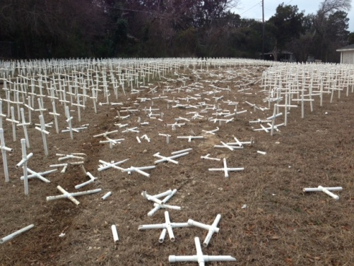**Rachael’s Park Memorial – Vandalized!”**

**“…He (satan) is filled with fury because he knows that his time is short.” Revelation 12:12b.**  The devil hates children – preborn, born – it doesn’t matter to him.  He hates all!  He desecrated even their memory on this 40th *Roe v. Wade* memorial.  Here is another example of his animus.

On Saturday, January 26th Rachel's Park Memorial, a memorial dedicated to the memory of the preborn babies murdered by abortion, was desecrated. A report was filed with the Waco Police Department at 11:09 am, by an employee of a neighboring business. Rachel's Park Memorial is located in Waco. The park has suffered regular desecration, but this attack was, by far, the most devastating.

Entombed within the park are the remains of a tiny victim of abortion. The spreading display of 4,000 white crosses reinforced with steel rebar was extensively damaged, as was the picket fence enclosing the memorial park. A swath of damage 12 ½ ft by 136 ft cuts through the memorial site, with approximately 600 crosses, rebar, oil, two tires, and parts of a vehicle's underside littering the park. Thankfully, the main feature of the memorial park, The Tomb of the Unknown Baby, was undamaged.

Rev. Rusty Lee Thomas, Founder and Director of Rachel's Park Memorial stated, "It appears the animosity against the preborn knows no bounds. Not only are we content as a nation to stand back and allow the preborn to die through the sin and crime of abortion, but now there are those among us who seek to destroy the very memory of these children as well. We pray the Lord will take this desecration and lead justice to victory and those responsible for this evil act will repent, find forgiveness in Christ, and make restitution."

**The Re-Opening of Tiller's Slaughter House** by Bruce Garren

After George Tiller’s death in May 2009, efforts began to bring child killing back to Wichita, initially under the leadership of late term abortionist Leroy Carhart and later under the leadership of Julie Burkart. Mila Means was the first doctor recruited but due to local resistance and lack of financial support the effort failed. Recently, plans are underway to reopen the old Tiller Clinic after remodeling under the name, *South Wind Women’s Center*. The remodeled clinic was to open on January 22, 2013. Due to resistance by local prolife organizations, that did not happen. They are now projecting the opening for this spring with three abortionists, one local and two out of state. Of course they have not revealed the names of these child murderers. We visited the neighborhood of Julie Burkhart in November. Recently,14,000 signatures were presented to the Wichita City Council asking that the *South Wind Women’s Center* be rezoned to prevent its opening. The Metropolitan Area Planning Commission is scheduled to consider the re-zoning issue on Feb. 21st.

**Keep storming the gates in Jesus’ magnificent Name.**