Easter in New Orleans
by Dale and Michelle Sochia
What an incredible Resurrection weekend! Rev. Flip Benham and his amazing wife, Faye, came to New Orleans for an awesome weekend of ministry and fellowship!
On Friday, March 29, 2013, we went to the Murder Mill in New Orleans with Rev. Flip Benham, Pastor Bill Shanks, and Pastor Dale Sochia and many, many precious and faithful warriors for Christ. We literally were at the very gates of Hell (see photo). Sadly, this was the busiest day we have seen at an abortion clinic in years. The girls were just flowing in there, like cattle being led to the slaughter. One girl came in and out several times and finally agreed to talk with us. Her warped logic was that she wanted to do things right this time (she already has a 1 year old) and do what's right as a mother and get married first and then have her baby. We tried to encourage her to give her baby up for adoption, but she said she wouldn't want someone else to raise her child and, again, she wanted to do the right thing as a mother. Her thinking was so confused and she was so deceived ... heartbreaking. Also, Brother Bill and Flip were able to confront the abortionist as she walked into the clinic and shared truth with her. This clinic has a huge window facing the sidewalk and the girls all sit right inside the window and can hear every word we say. We were able to share God's truth, His hope, and His love for over 2 hours to the girls sitting in the waiting room. We did not see any women leave that day, but pray that their hearts were pierced and they fall to their knees in repentance.
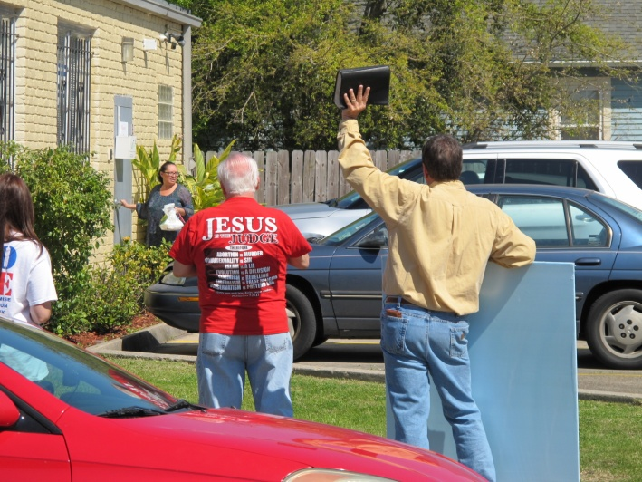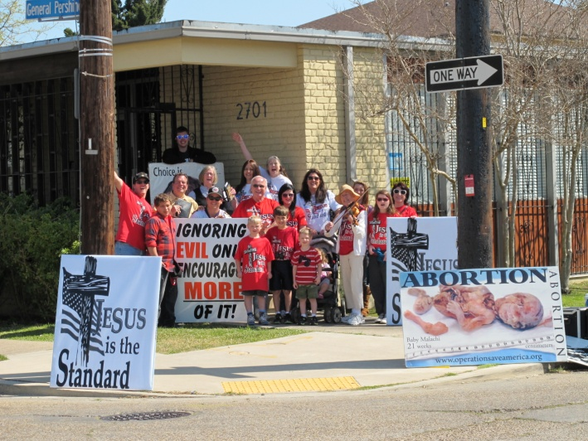
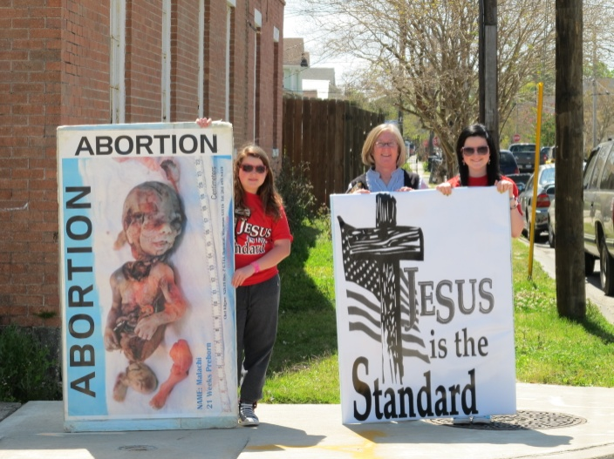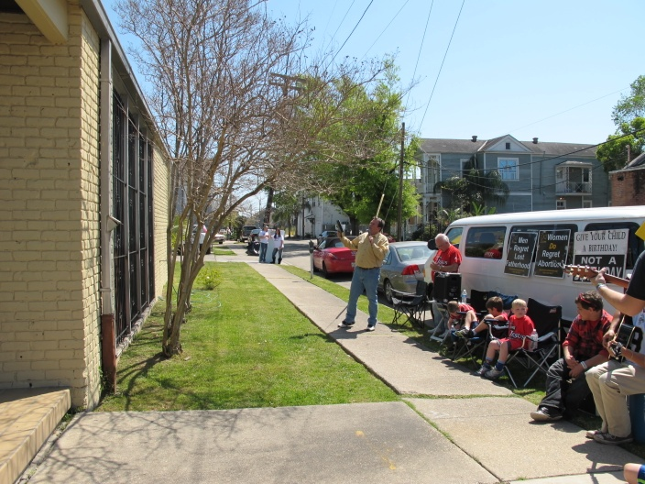
From the New Orleans abortion clinic, we then all took a road trip to Hattiesburg, MS, to join Brother Cal Zastrow and the saints in MS in front of the proposed site for a new Planned Parenthood. Rev. Rusty Thomas, Jan Villavaso and her family, Richard and Melody Miller, Cal Zastrow and his family, and many of the saints from MS joined us as we lifted up the name of Jesus in front of PP. There were eleven police cars in front of PP! The police stood and watched and listened as we worshipped the Lord and as men preached and prophesied that not one baby would ever die in this building! Please stand with us in prayer, believing that God will supernaturally shut this place down and not one child will ever be killed in that building!

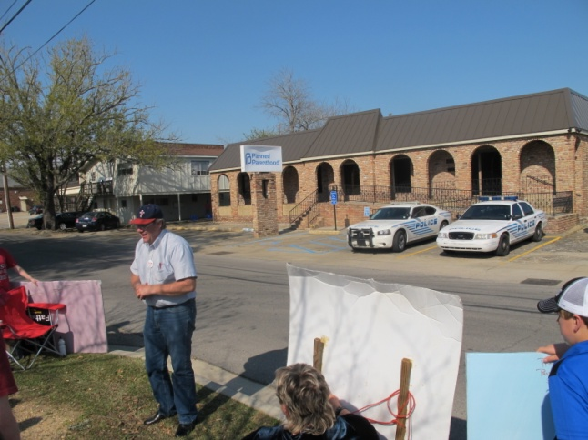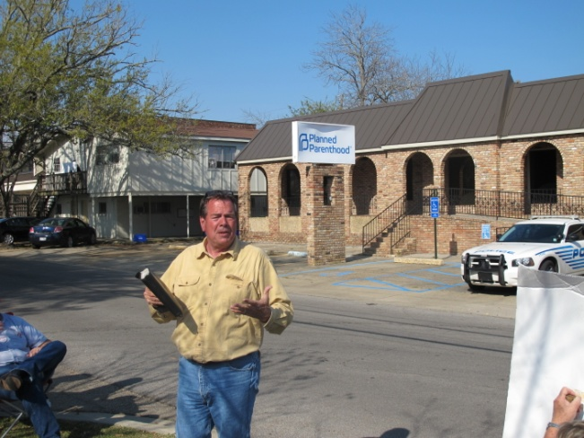

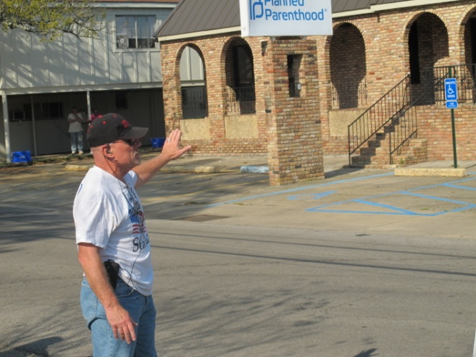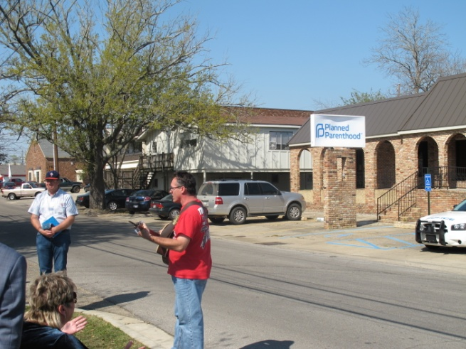

Then, on Saturday morning, we all went to the Ridgelake murder mill in Metairie. They were killing that day also, but it was much slower than the New Orleans clinic yesterday. One woman, who had already had her abortion last week , came back for a check-up. When she got out of the car, she immediately walked over to Dale and Flip. She was very broken and remorseful. She gave her life to Jesus that day!!! (see photo below) Glory! There were also 2 other ladies who left the clinic that day and chose not to kill their babies! Praise God!!
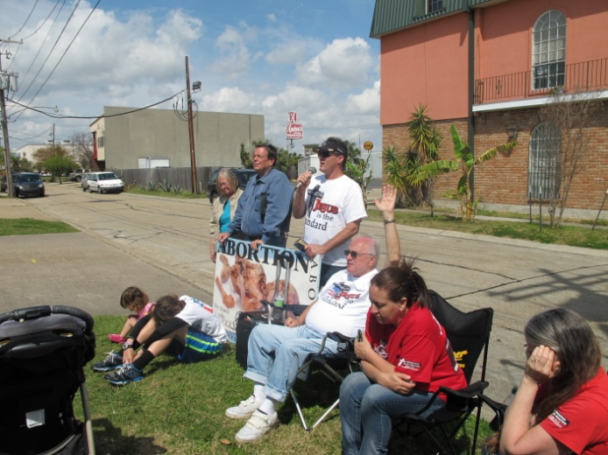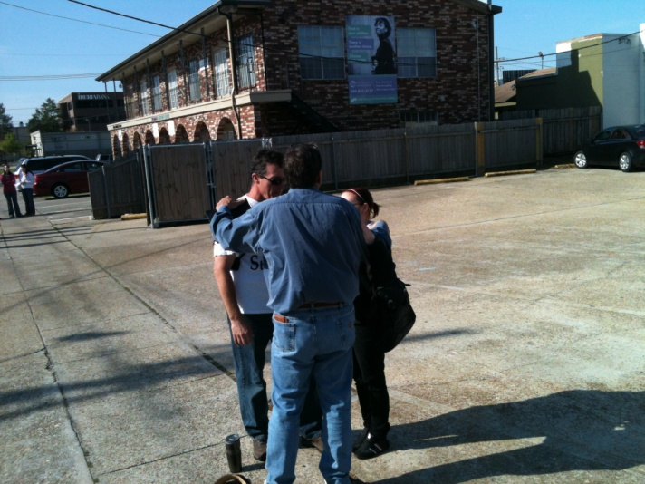
On Sunday, Brother Flip preached a powerful message on how some may need that second touch by Jesus in order to see clearly (Mark 8:23-25). Many answered the altar call and committed to read the Word of God every day and three people expressed a desire to give their lives to Jesus ! The presence of the Lord was at the service and lives were touched and forever changed!!
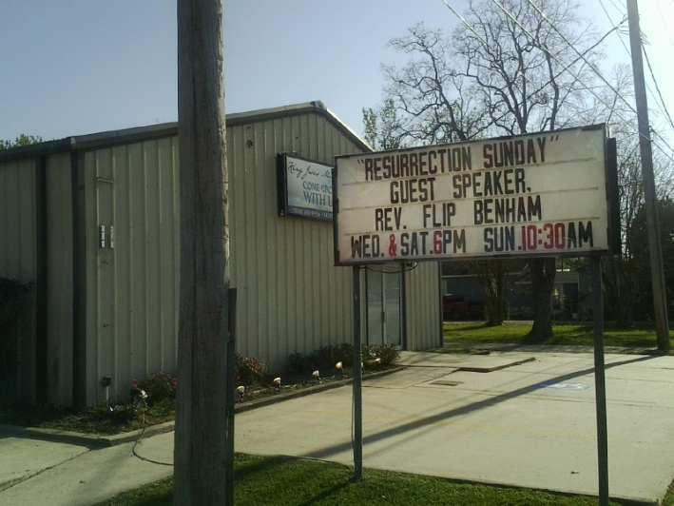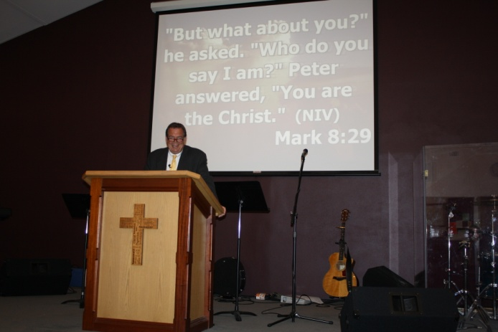
After the morning service, we had a crawfish boil. We still couldn't get Flip to eat crawfish, but he is getting close ... he admits to liking the way the seasonings smell and enjoyed the potatoes and sausage that were boiled with the crawfish. Dale peeled some crawfish for Faye and she ate them!! Go Faye!! Flip's favorite New Orleans foods were the Beignets (fried dough with powedred sugar, Nawlins -style). We don't blame him ... they are delicious!
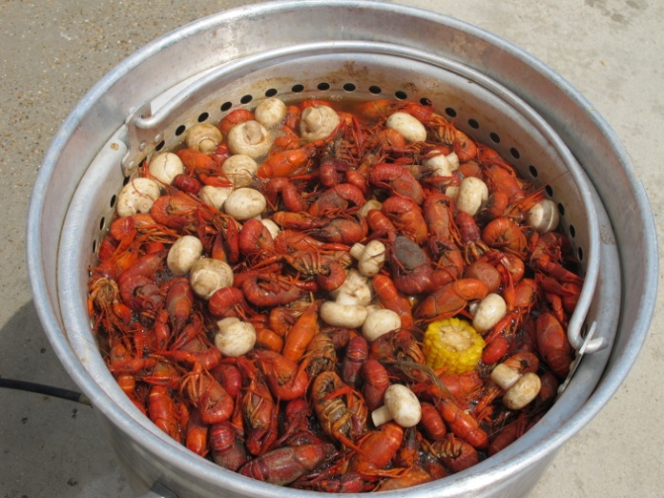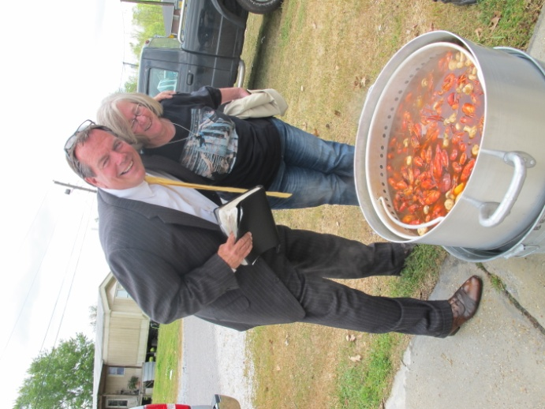
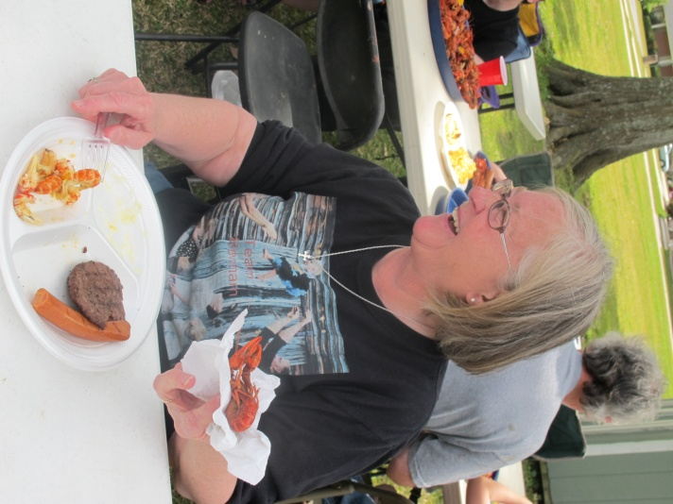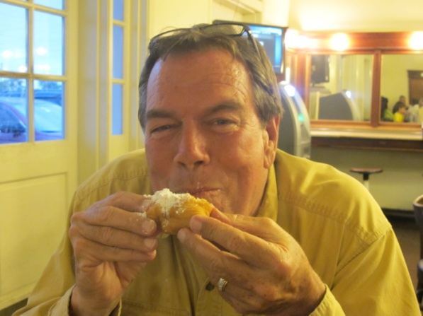

Thank you Flip and Faye for coming to New Orleans for a powerful weekend of ministry! And thankful to the Lord for all the precious, faithful saints of God from New Covenant Fellowship and King Jesus Ministries who joined us on the front lines! All the glory goes to God for such an awesome weekend!

