June 2013
Mike Warren sounding the trumpet: “We are preparing for the Operation Save America event here in Rochester, New York, July 24-31st. We are seeing a renewed awakening of God’s pastors and His people to their responsibility for the least and the most defenseless among us. The connection between bloodguilt and the trials facing our city is beginning to resonate within God’s church. There is a powerful conviction of the Holy Spirit to rescue those being led away to the slaughter. We must repent, pray, and act! Evil must be confronted with the righteousness of Almighty God. We believe we will see the deception covering the abortion industry here in Rochester – blown away. The Light is arising and beginning to Shine. God speed you here!
“The wind blows where it wishes and you hear the sound of it, but do not know where it comes from and where it is going; so is everyone who is born of the Spirit.” John 3:8
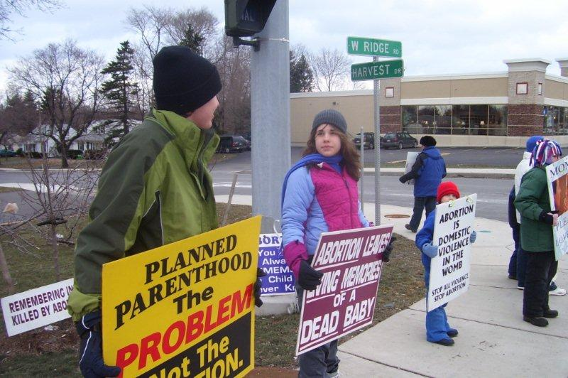
The wind of God’s Spirit is blowing in our city and in our nation. Come and walk where Charles Finney preached revival and reformation during the dark seasons of slavery in our nation. The city of Rochester was turned upside down by the powerful preaching of the Gospel of Christ. Jails were emptied, saloons were closed, and churches were packed. Rochester became a vital stop on the “Underground Railroad.” It was the home of former slave and abolitionist leader, Fredrick Douglass.
The Governor of New York, Andrew Cuomo pledged to expand abortion in New York, removing any limitations. He actually led a pro-abortion cheer during his “State of the State” speech. He desires New York to become the national champion of abortion.
What better place for the saints of God to storm the gates of hell? Rochester boasts of six abortion mills. We have a “doctor” who actually advertises on TV. We will visit him and others with the Gospel of Christ. “Arise, shine for your Lord has come. And the Glory of the Lord has risen upon you!” Isaiah 60:1. Now we will see what God will do!
More and more Churches and pastors are willing to host our rallies and participate with us on the streets. You will encourage them greatly. Make plans now. Each year our family attends the annual OSA event and each year the Lord enabled us to go. Friends and churches respond to our mission support letters in amazing ways. I’m sure the same will happen if you will ask. “Then sang Deborah and Barak … on that day, ‘“That the leaders took the lead in Israel, that the people offered themselves willingly, bless the Lord!” Judges 5:1-2.
Miracles In Charlotte on May 13, 2013
The abortion mill (A Preferred Women’s Health Center) on Latrobe Dr. in Charlotte, North Carolina was shut down by the North Carolina Department of Health and Human Services. Many of you spent time at this mill intervening on behalf of our Lords’ precious preborn children last summer at our National Event. Thank you!
All charges (stalking) against me have been dismissed by the Charlotte District Attorney. Dr. Harvey Harris and Dr. Curtis Flood have both stopped doing abortions in this city or anywhere else. They had no choice – they lost their insurance. This all happened yesterday, May 13, 2013 – the 40th year of Roe v. Wade. Oh, and abortionist Kermit Gosnell was found guilty on three counts of first degree murder this day. No longer do we have to envision abortionists on trial or in jail – it is actually happening.
“Now see what the Lord will do!” Rusty Thomas gave us this verse, “Then the Lord said to Moses, ‘Now see what I will do…’” Exodus 6:1. Rejoice with us brothers and sisters. Look what the Lord has done!
North Carolina Abortion Clinic Shut Down by State as ‘Imminent Danger’ to Public Health
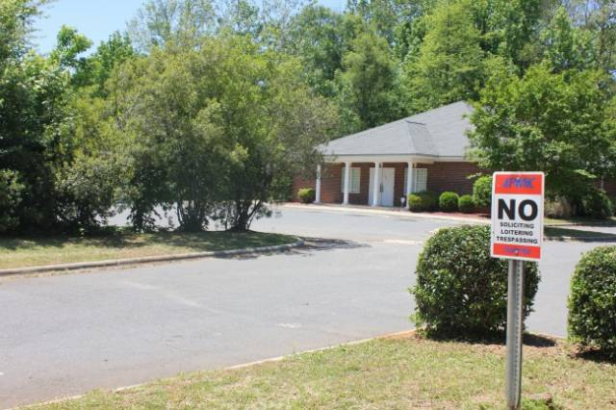
By Kirsten Andersen, Life Site News, May 14, 2013 17:30 EST
CHARLOTTE, NC: A Charlotte, North Carolina abortion clinic has been closed following an investigation that revealed abortionists were incorrectly giving abortion drugs to their clients. Workers at the “A Preferred Women’s Health Center” were found to have given injectable methotrexate orally to abortion-seeking women, in violation of FDA and manufacturer guidelines.
Methotrexate is a powerfully toxic anti-cancer drug. The wrong dose of methotrexate can cause severe complications, such as incomplete abortion, heavy bleeding, liver damage and even death. At least one woman at the clinic was forced to undergo surgery after a botched methotrexate abortion, according to the state report.
State investigators also found that the abortion center had shoddy follow-up practices, repeatedly failing to examine women to ensure that no fetal body parts or other pregnancy-related tissue were left inside their wombs after abortions.
The North Carolina Department of Health and Human Services hand-delivered a letter to the abortion center on May 10 ordering them to shut down the facility by 5 pm the same day. The letter explained that the health agency had determined that the abortion facility presented “an imminent danger to the health, safety and welfare of the clients and that emergency action is required to protect the clients.”
This is the second time in six months that “A Preferred Women’s Health Center” has been the subject of a state investigation. In December, the clinic was cited by the department of health for safety violations including unsafe storage of hazardous materials, emergency medications being expired, and failure to properly sterilize instruments including vaginal speculums, which investigators said were stored in a plastic bin that “contained debris.”
The abortion center was also the source of racial controversy last year when abortionist Ashutosh “Ron” Virmani confronted pro-life activists in front of the clinic and told them that anyone who opposes abortion should “adopt one of those ugly black babies” and get them “off the taxpayers’ money.”
Rev. Flip Benham of Operation Save America, who has been organizing prayer vigils and literature drops at Charlotte-area abortion centers for years, held a press conference in front of the now-closed clinic today in which he thanked local churches for their faithful prayers and pro-life activism. In a phone interview with LifeSiteNews, Benham said that he sees a sea change coming in the way Americans view abortion.
In the wake of the capital murder trial of Kermit Gosnell, an abortionist who severed the necks of babies who survived sloppy abortion procedures, and in the aftermath of a number of high-profile clinic closures, Benham believes more Americans are starting to realize that gruesome stories of unsafe, unsanitary clinics are more the rule than the exception in the U.S. abortion industry. “Abortionists [today] are the back-alley abortionists of yesteryear,” said Benham. “They’ve just crawled out from underneath that rock because [abortion is] legal now. If the health department would inspect every clinic and hold them to the same standard as even a veterinary clinic, they’d all be shut down.”
Benham argues that the 1973 Roe v Wade decision gave a fundamentally criminal industry legitimacy in the eyes of the law, and says safety violations, drug violations, and disregard for the law are endemic to the industry. Added Benham, “This is a filthy, disgusting business. It’s not that Gosnell is an anomaly or an aberration. It’s endemic to the industry itself.” He called for gentle Christian warriors to be strong in faith
as they storm the gates of hell and credited local churches’ prayer and activism for the closure of the Charlotte clinic. He said that abortion will last as long as people of faith allow it to continue in their own communities. “The solution will not be found within the beltway of Washington, D.C. It isn’t there that the battles are won. They’ll be won in the streets – every day – and they’ll be won as gentle Christian warriors – moms and dads, grandmas and grandpas, little boys and little girls – bring the Gospel of Christ right to the gates of Hell.”
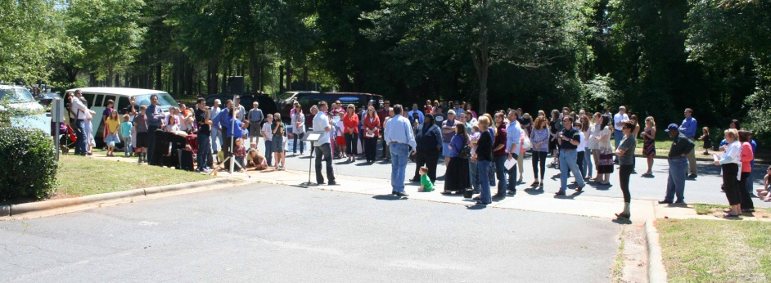
Celebration & Memorial Service
The atmosphere was electric, charged with the glory of God, as we approached the completely empty parking lot of “A Preferred Women’s Health Center” at 3220 Latrobe Drive in Charlotte, North Carolina. This abortion mill just had its license suspended by the North Carolina Department of Health and Human Services. Over one hundred gentle warriors for King Jesus (moms and dads, grandmas and grandpas, boys and girls) began to fill the street in front of this awful place where thousands of little baby boys and girls have been slaughtered. It had been closed for four consecutive days and on this day – Tuesday, May 14, 2013 – it was shut up tighter than a drum.
The incredible prayers, the sounding of the shofar, the shouts of joy, the music, the explosive testimonies of what our Lord had done, the praise and worship filled the whole neighborhood with the high praises of Almighty God. We were overflowing with the joy of the Lord and it would not be contained. Indeed the joy of the Lord had become our strength (Nehemiah 8:10). Little did we know how much we were going to need it.
We found out last night that the abortion mill filed a “petition for a contested case hearing” with the Office of Administrative Hearings in Raleigh, North Carolina. A Preferred Women’s Health Center was granted a stay and will open its doors again May 15, 2013, to resume the murder of God’s precious preborn children.
We need all of our gentle warriors back on the front lines today. If it is inevitable that little children must die, it is imperative that they do not die alone. Joel Osteen wrote a book not too long ago titled, “Your Best Life Now.” God wrote a book longer ago that showed us “Our Best Life Later”
“All these people were still living by faith when they died. They did not receive the things promised, they only saw them and welcomed them from a distance. And they admitted that they were aliens and strangers on earth…they were longing for a better country – a heavenly one. Therefore God is not ashamed to be called their God, for he has prepared a city for them.” Hebrews 11: 13-16.
Come on “church militant!” Put on your armor and sharpen the Sword of the Spirit. We have a battle to fight and to win in the strong Name of Him who for the joy set before Him endured the cross, despised the shame, and is now seated at the right hand of the Father. You will find peace and rest later (in Heaven) but today we are called to deny ourselves, pick up our cross, and follow Christ. Our best life is later!
Saints Arrested in Florida for Proclaiming Christ! Sun, May 19, 2013 byJay Rogers <jcr4runner@gmail.com>

My friend of 20 years, Pat McEwen, was simply standing on a sidewalk and reading her Bible. I was taking video of a pro-life march. Cheryl Bischoff was celebrating LIFE in front of the home of a Planned Parenthood executive on Aloma Ave in Winter Park, Florida -- a four lane highway in an upper class section of Orlando.
Apparently, the city SWAT Team decided we were violating a "no picketing" ordinance. Yes, they called the Winter Park SWAT team on us. The regular police were not good enough. Actually, they were really nice guys. One of them described his training with machine guns to us later as we were being booked. When we got to the police station in Winter Park, they were trying to find a copy of the ordinance that they arrested us for. The Winter Park SWAT Team had a big discussion about what to call our crime. Finally, they decided on "Picketing in a Prohibited Area."
I was hoping for "Conspiracy to Commit Loitering," This would mean that we were planning to do nothing. But they didn't take my advice. I also got to preach to about a dozen jail workers. I had to give my religious preference when I checked in. I asked: "What have you got?" I looked at the list and I picked "evangelical" -- I explained what it meant. I said it means that you believe that "You must be born-again." Very soon, I had about seven of the processors gathered around me wanting to know why I'd go to an abortionist's home and get arrested. We talked about the murder case in Tampa. It's fascinating. It turns out that federal law says that killing an unborn first trimester child is murder.
We also talked about God's Law, being "born-again," and the whether the death penalty is biblical. Not necessarily in that order. On my release, the processor asked me to repeat my name, DOB, and reason for arrest. I said, "John Rogers, 6/24/62, Standing for Jesus on a sidewalk."
I later found out that we had the largest Awareness Campaign a few blocks east at Winter Park Memorial Hospital where abortionist Emil Felski is on staff. Later many of these humble saints of God came down to the Orange County Jail and picketed and prayed where we were being held for few hours. http://youtu.be/AznFVRCFjys

“Agape Defiled: How the Church has Failed 55 Million Orphans” by Rolley Haggard May 7, 2013
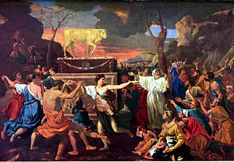
“There's an elephant in the living room. Only it isn't an elephant, and it isn't in the living room. It's a golden calf, and it's in our baptismal font and our pulpit and our sanctuary and our Sunday School class and our Bible study group and everywhere else we worship and serve God, because, truth be told, it's in our hearts. To put it bluntly: We, the church of Jesus Christ, have an idol. It's called ministry.
Ministry? Yes, ministry: busying ourselves with the things of God. Granted, ministry seems very un-idol-like. But then, subtlety is the hallmark of seductive sins. I t has been the devil's most effective stratagem since the beginning of time: Get the sin to seem no sin. Better yet, get it to seem like service to God. Better even still, get it to be service to God. Sins don't get more subtle than that, nor does idolatry seem like idolatry when we're busy doing things God instructed us to do. It seems like true Christianity, like pure and undefiled religion. But is it? Even ministry can be idolatry when it supplants what God most wants from us. What is the acid test of true Christianity, of pure and undefiled religion? What does it look like?
Pure and Undefiled Religion. We are not left guessing. In James 1:27, God tells us what “pure and undefiled religion” looks like: “Visit[ing] orphans and widows in their distress.” That's divine shorthand for serving “the least of these” with sacrificial agape love. Acts of compassion, exemplified by coming to the aid of suffering women and children, are the distinguishing marks of true Christianity.
The American church, by stunning contrast, has been characterized the past 40 years—ever since Roe v. Wade—by the deliberate and thoroughgoing neglect of 55 million orphans in exquisite distress. One has to wonder if the cold indifference shown by the church to these orphans could have been any more absolute had salvation itself depended on completely ignoring them.
Orphans? Yes, orphans, in the truest sense. These little victims, before having their lives snuffed out by abortion, were emphatically orphans, for there are two ways a child becomes an orphan: One is to lose his parents; the other is for his parents to abandon him. It doesn't take a Solomon to see here the applicability of James 1:27. Yet for four decades the church has fastidiously refused to muster aid on behalf of these little people and against one of the most barbaric and inhumane practices imaginable. Not only has the church opted not to visit these orphans in their distress, but by refusing to voice any significant public moral objection, the church has actually gone to the opposite extreme and given tacit sanction to their cruel mutilation and murder.
And this comports with James 1:27, how? No one will answer that question because there is no answer. We are wholly without excuse. We have ignored not only the soundless cries of these abandoned orphans, but more ominously, the unequivocal declarations of our God and Father as well.
This raises the additional and perhaps more deeply soul-probing question: If pure and undefiled religion in God's sight is to visit orphans in their distress, then just what kind of religion has the church been practicing since 1973? What kind of religion is it whose defining characteristic is the refusal to visit tens of millions of orphans in their inconceivably great distress?
The logic is inescapable: If pure and undefiled religion in the sight of God is to give compassionate, sacrificial, agape love to abandoned children, then American Christianity is grotesquely impure and defiled—like a river of life befouled by the corpses of too many children for even the angels to count.
Keep storming the gates in Jesus’ magnificent Name – see you in Rochester, NY this summer!

